**Task1: Data Retrieval**

To perform this task i am choosing android-games.csv dataset and this data set has data of around 1730 android games. So we perform our all task in Rapid Miner tool.

So the first operation we perform is data Retrieval.

Data Retrieval:-

Data Retrieval means to retrieve the data from the destination

First of all we have to open Rapid Miner Then we see

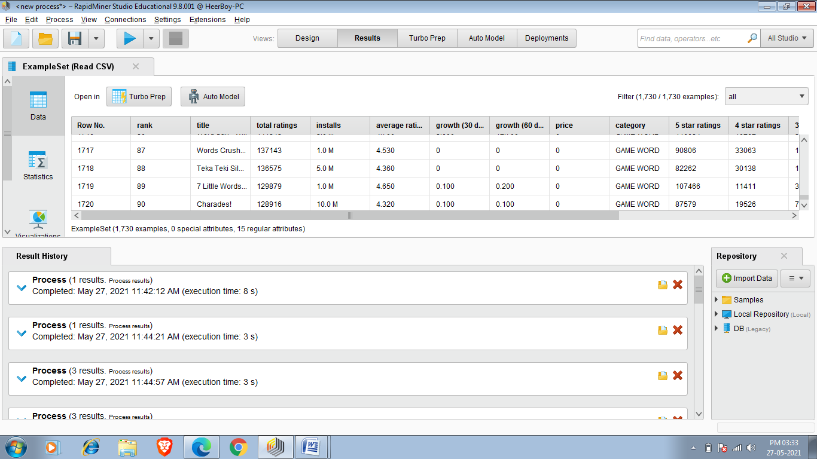 this icon and File option on left hand side of the working window then we have to click on one of them after clicking we have to click on blank process in this way we created process.

New process Created

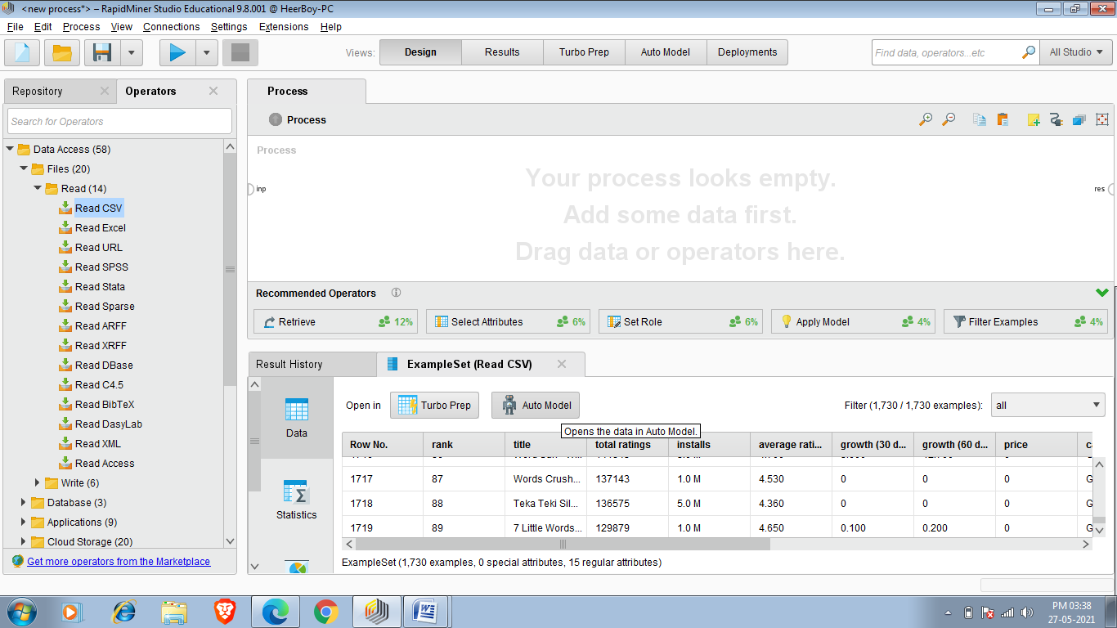

After creating process we have to insert read csv to read our data and then we have to choose the directory of the data and we have to insert it.

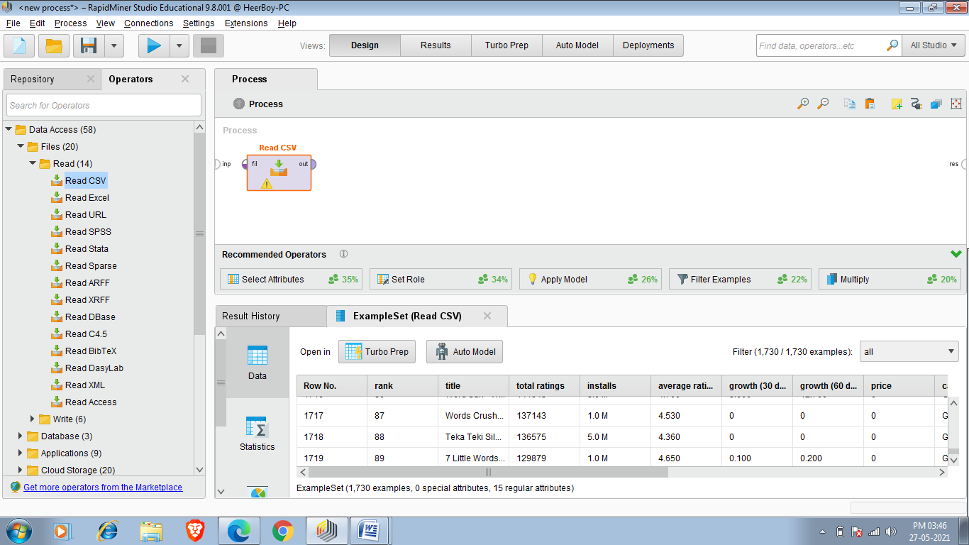

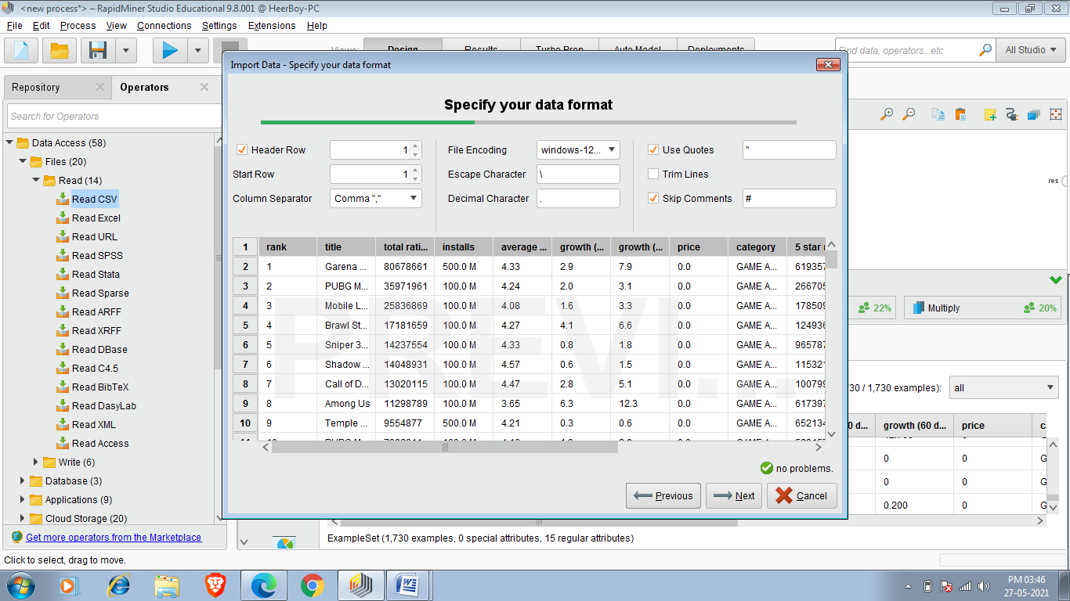

After selecting data we have to connect out of Read CSV to res and we have to run statement by Run button which is in upper menu or we run it by f11 shortcut key.So below is image of data retrieval.

**TASK 2:Replace Missing values**

To replace missing value in rapid miner we use Replace Missing Values operator

1.Do the same as i did in first task but now i am choosing cardekho_cleaned.csv dataset (19544 entris)after running it we saw that there is some missing values which can create some difficulty in further operations so we have to replace that missing values. Required dataset

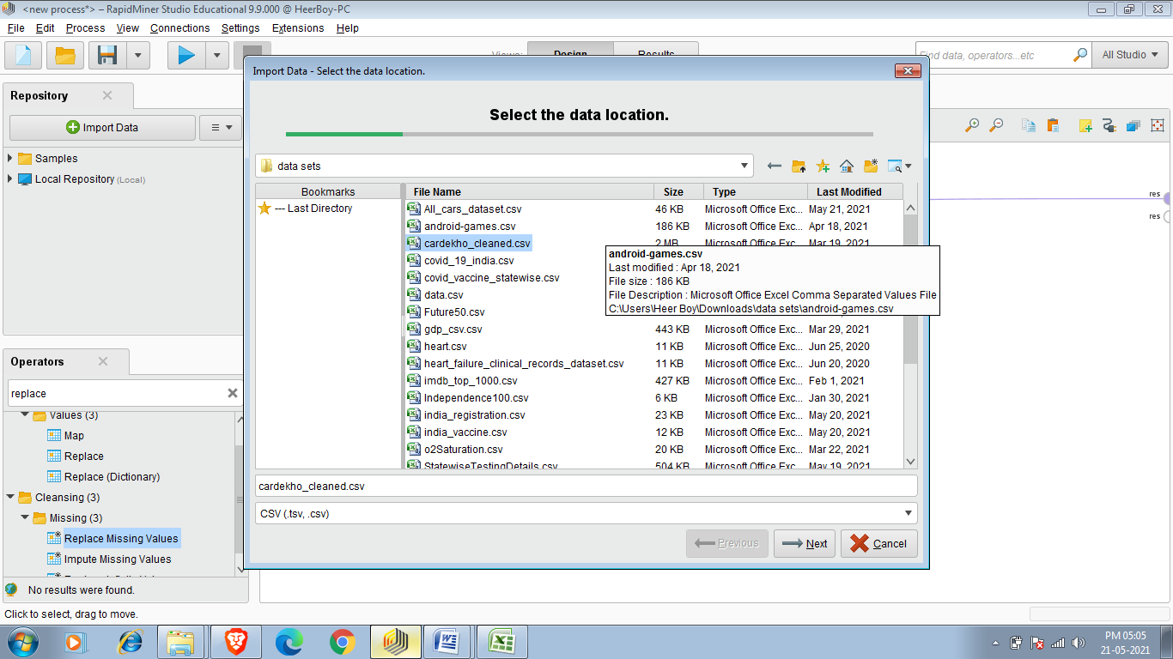

1. Click on operator search panel and search Replace Missing Values and

double click or drag it .

. 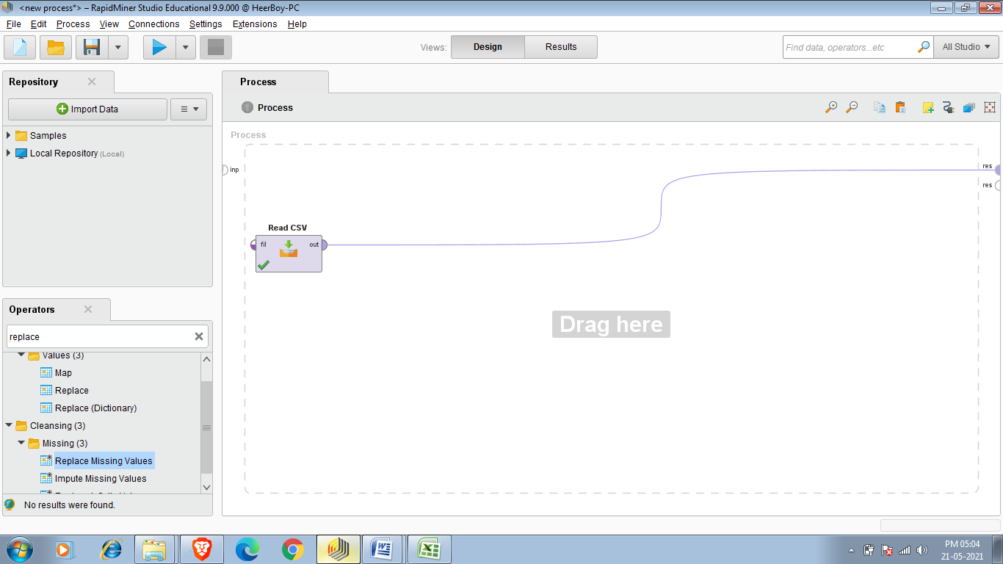

3.Connect out of read csv to exa of Replace Missing Values.

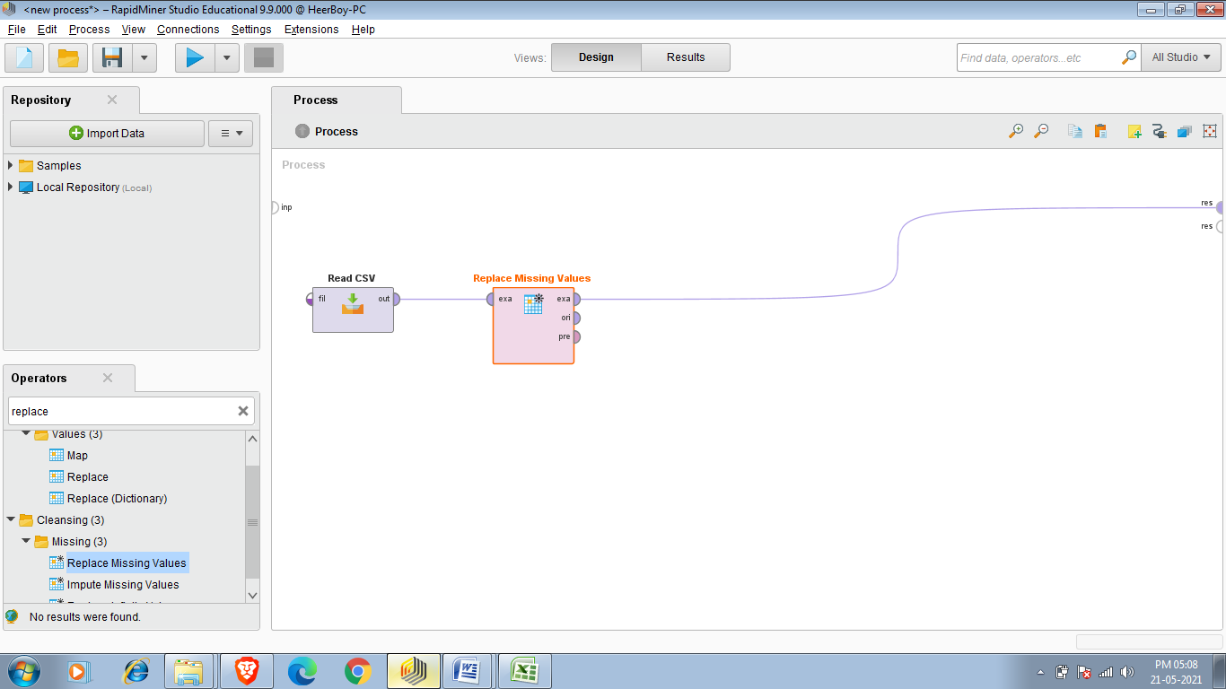

4.Connect exa of Replace Missing values to res.

5. After that run process you saw Example set which is created after replacing missing values.

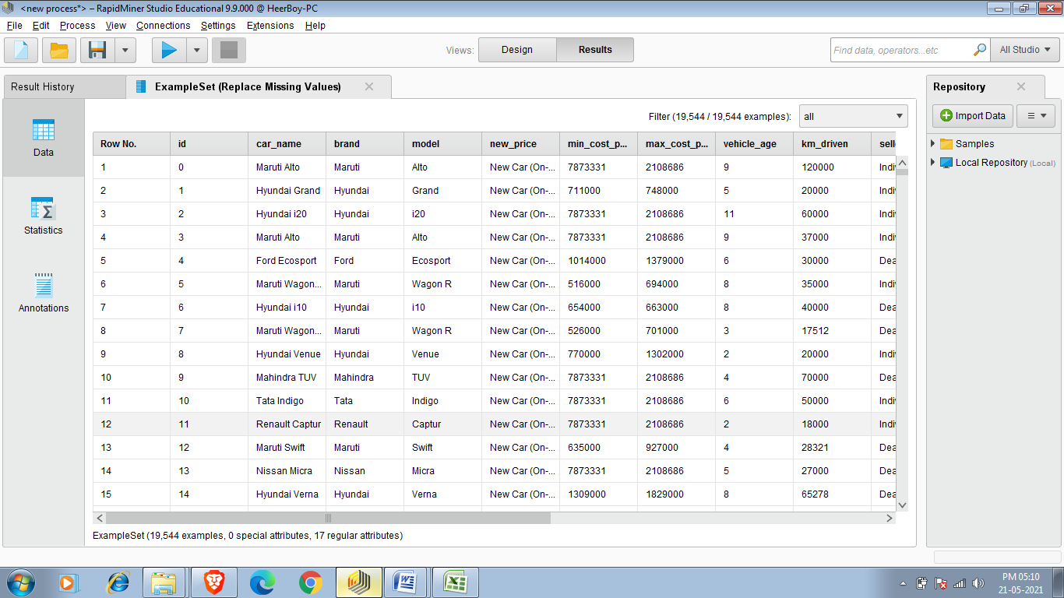

Task 3:Select Attributes (Selection)

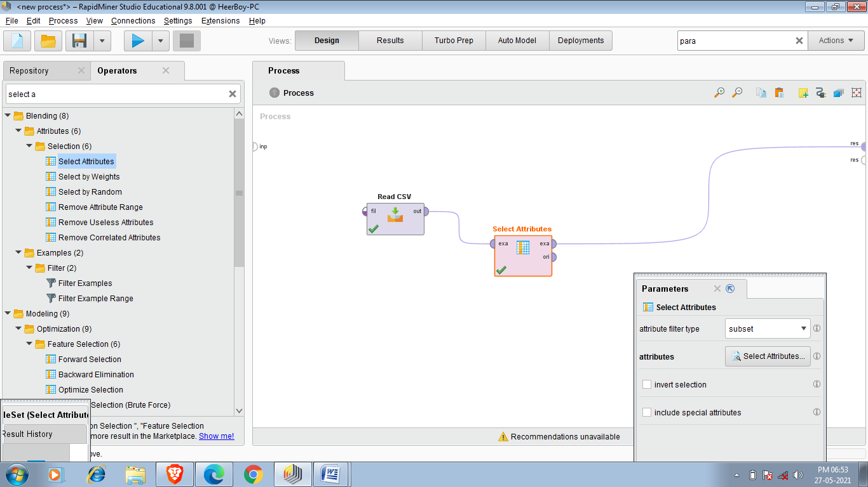

We can select our required Atribute and we perform that task by Select Attributes operator. So first of all have we have to make process then we have to add read CSV operator and then we have to choose directory as we done in first task.

Then we have to insert operator named Select Attributes and we we can choose single attribute, Subset of attributes, regular expression ,value type and many more .

I have Choosen Android-games.csv and i am selecting Average Rating,Paid and title attributes as shown in below

Figure.

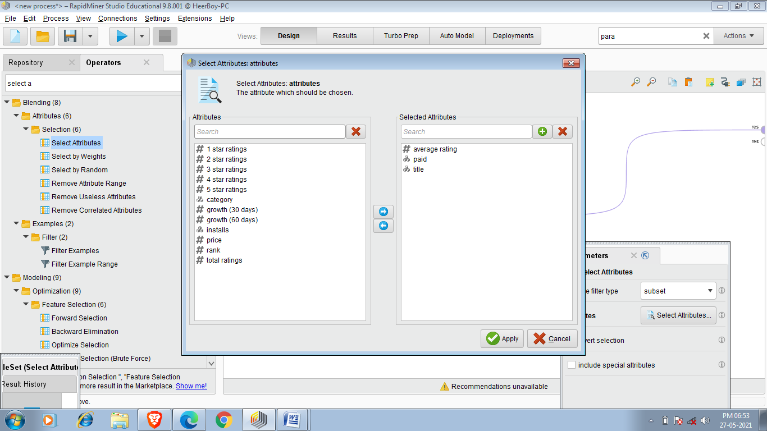

Final Result is shown below:-

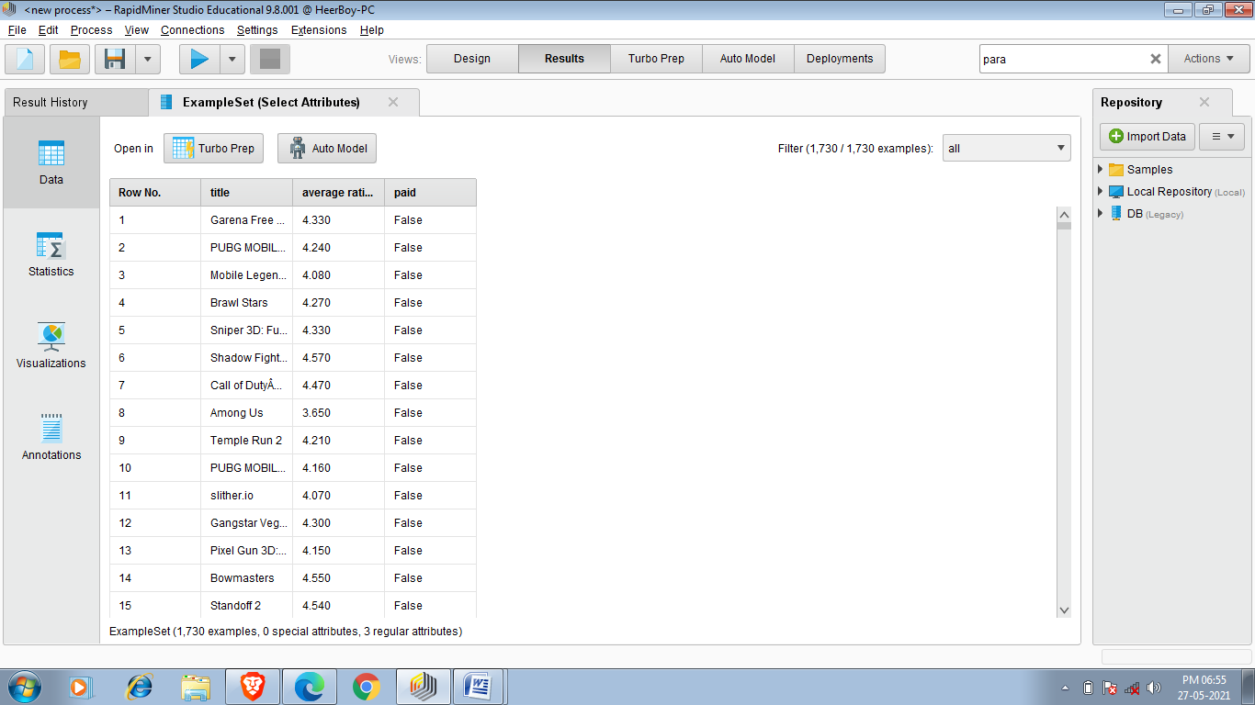

TASK4: Sort(sorting data)

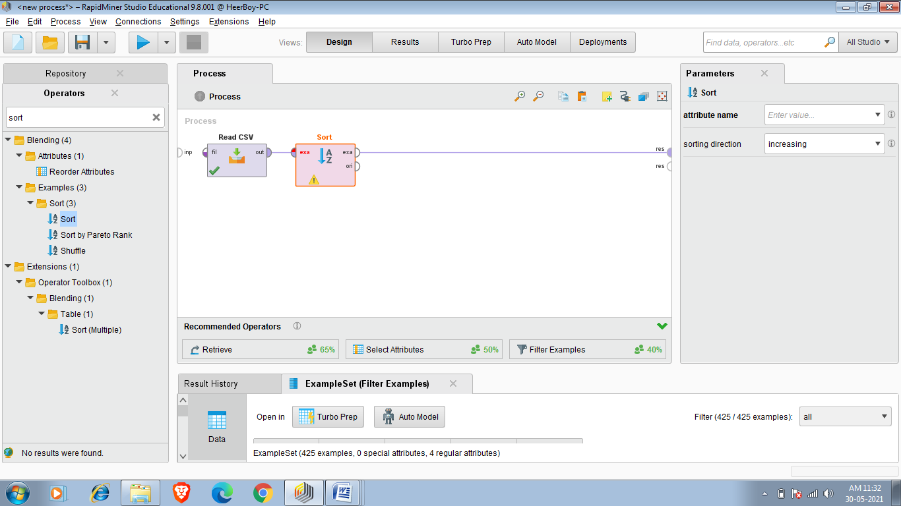

This operator sorts the input data set in ascending or descending order according to several attributes.

**Description**

This operator sorts the data set provided at the input port. The complete data set is sorted according to a single or more attributes. The attributes to sort by are specified using the sort by parameter. For each attribute, sorting is done in ascending or descending order, depending on the setting of the sorting order parameter. The resulting data set is sorted by the first attribute, then subsets of the same value in the first attribute are sorted by the second attribute etc.

So my task is i want to see Covid deaths of States and sort according to decreasing Deaths .So this tasks result tell me which state has more death as of 19 May 2021.

Initial Dataset:-

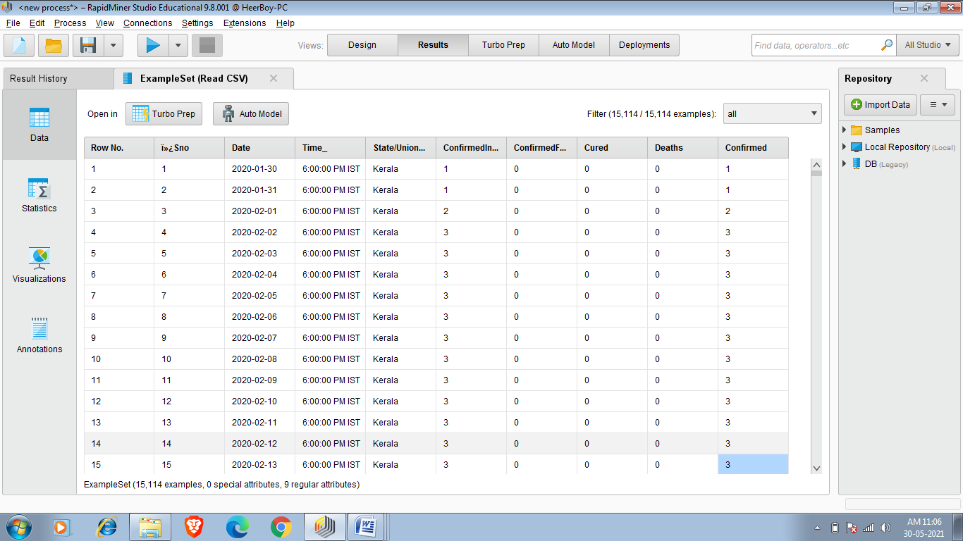

So i am applying Filter as shown below.

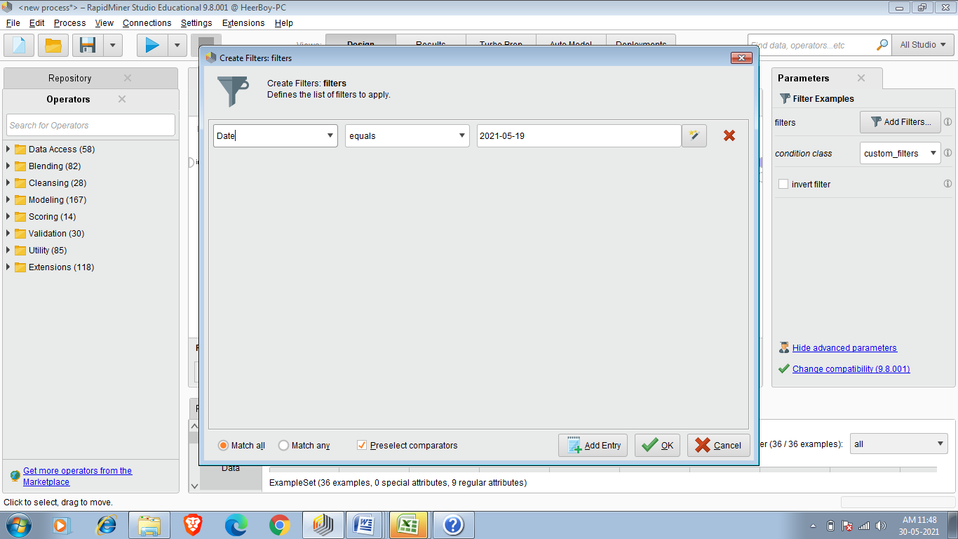

So i am Sorting in decreasing order of deaths .

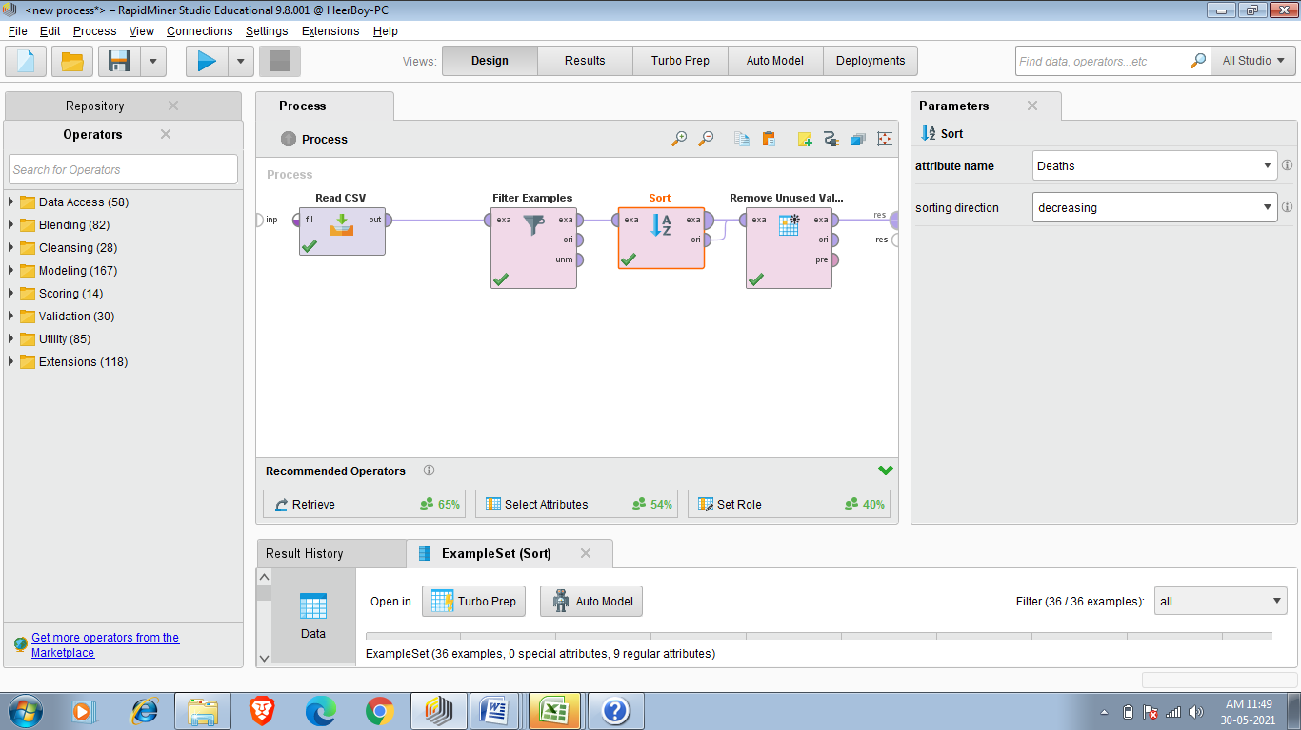

So final result is below:-

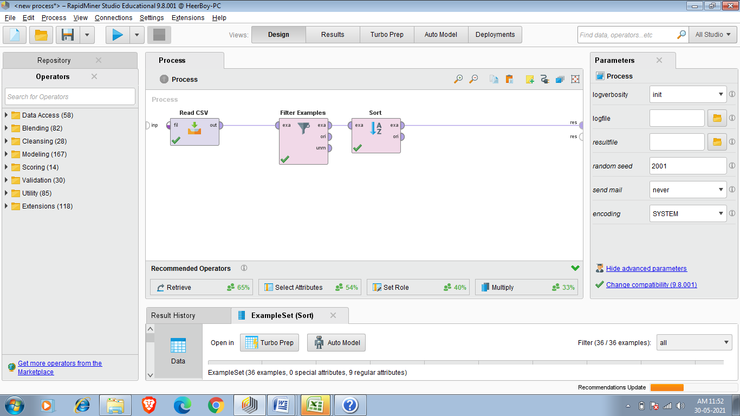

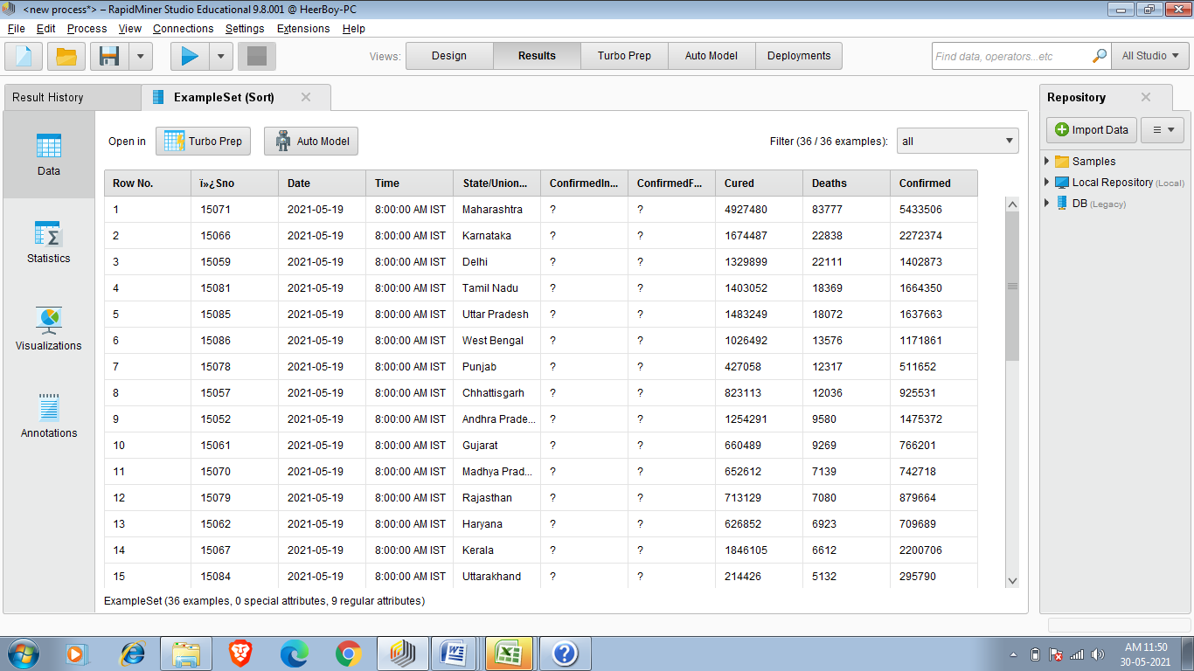

So we found that Maharastra,Karnataka,Delhi,Tamil Nadu and UP are having most number of deaths.

**TASK 5:-Reduce number of observations**

Sometimes we require only specific observations.for eg. In cars data set there is attribute which contains data of seats so we only want to see those cars which have five seat or taking another example we only want to see cars data whose brand maruti.

So to complete This Task we use Filter Examples operator .

1.so first thing is to create new process and then selecting our data set in this example i am using cardekho_cleaned.csv.

2.our second step is to reduce missing value by using Reduce Missing Values operator for better results.So connect Out of Read CSV to Exa of Reduce Missing Values.

3. After that search on operators search panel for Filter Example and insert Filter Examples operator and connect exa of Reduce Missing Values to exa of Filter Examples. After that double click on Filter

Example and apply appropriate filter on specific attribute.

So i am applying filter to brand attribute and the filter is equal to and the brand is equal to Maruti .So result show all values of attribute brand whose brand= Maruti .So result shows 5547 entries.

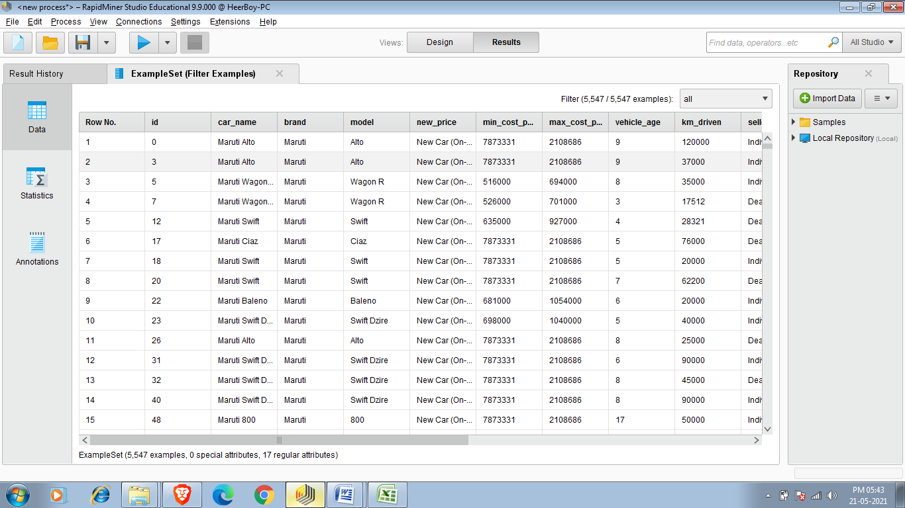

Now my requirement is that i want to see those car whose age not more than 4 year and fuel type is diesel and seating capacity is 7 and have atleast 18 mileage so we use 4 filter example which will help to get our desired result because i want to self analyse the price of car as per my requirement.

Filter 1:-

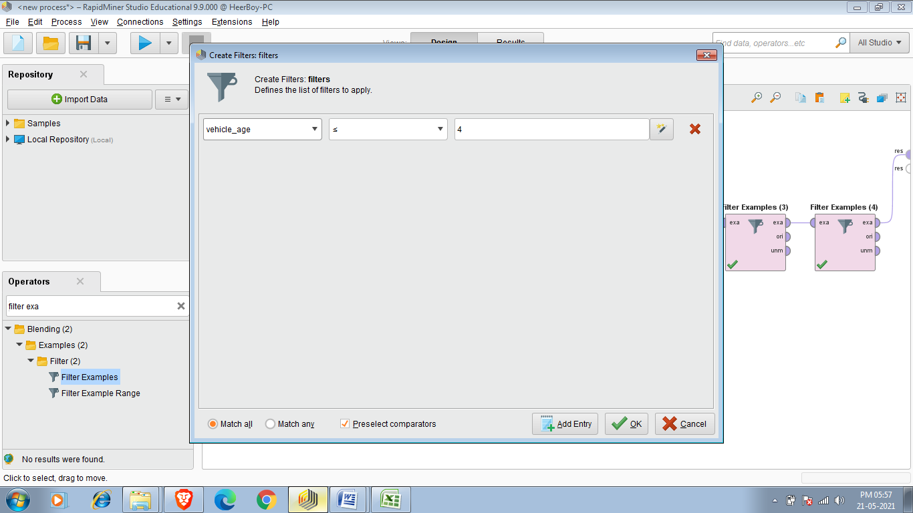

Filter 2:-

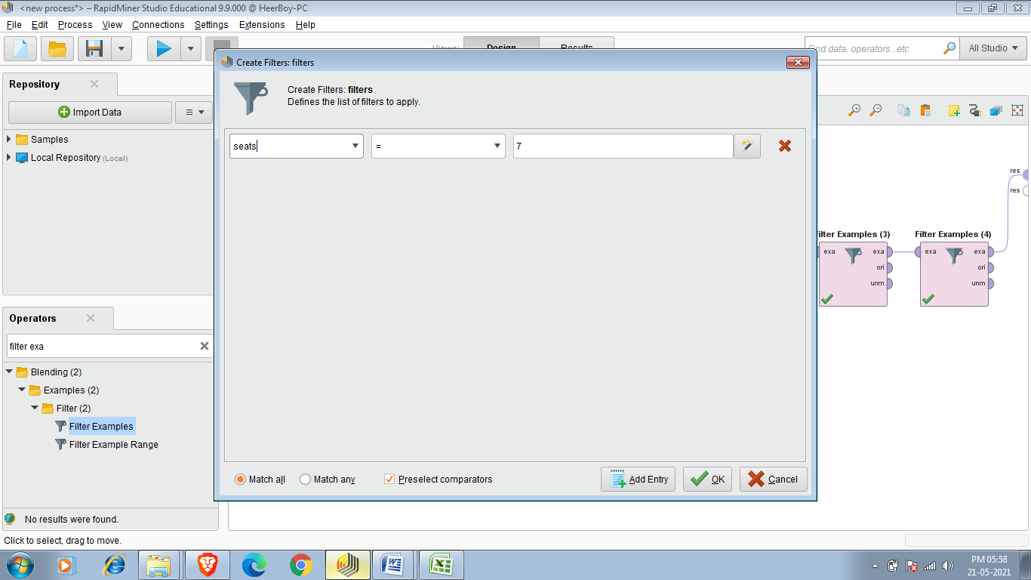

Filter 3:-

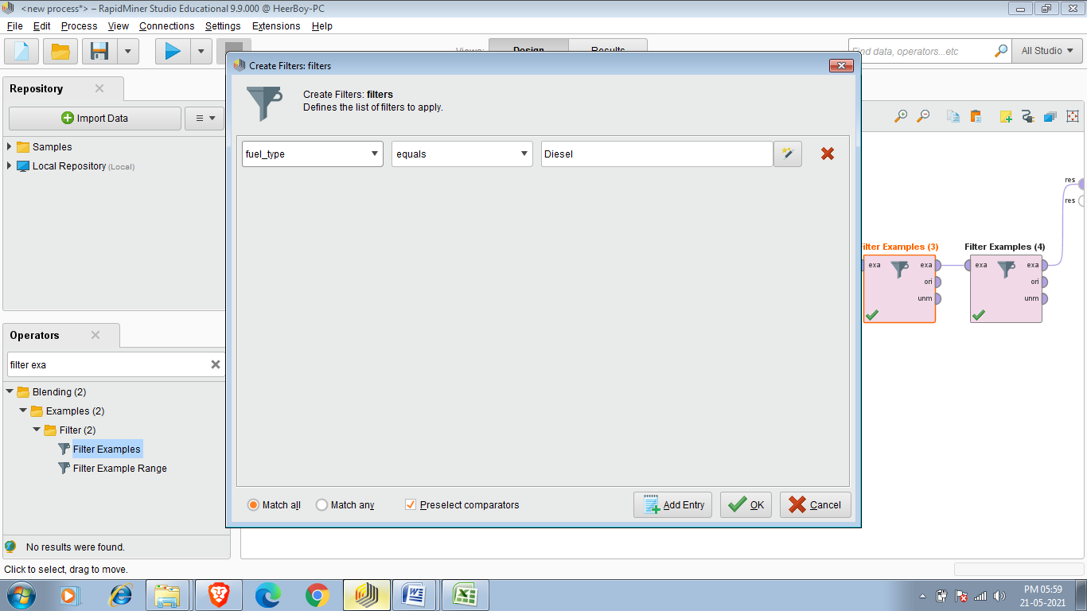

Filter 4:-

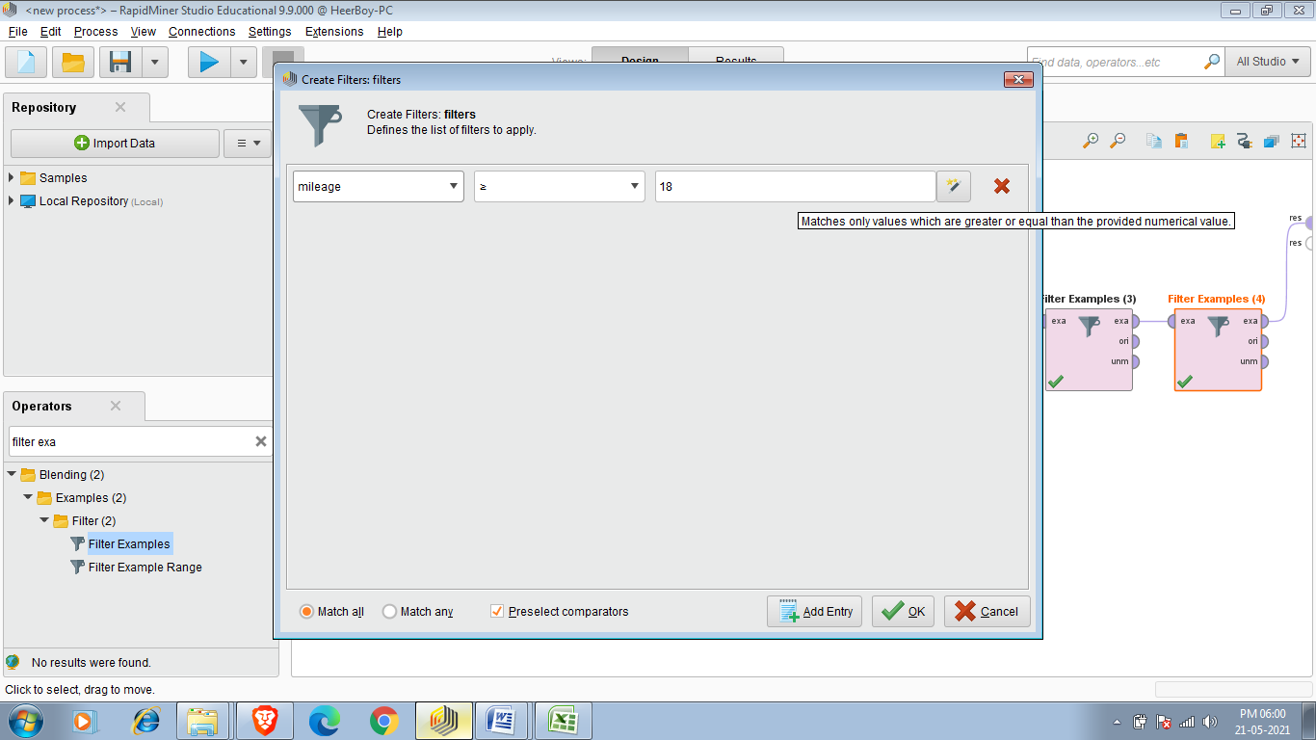

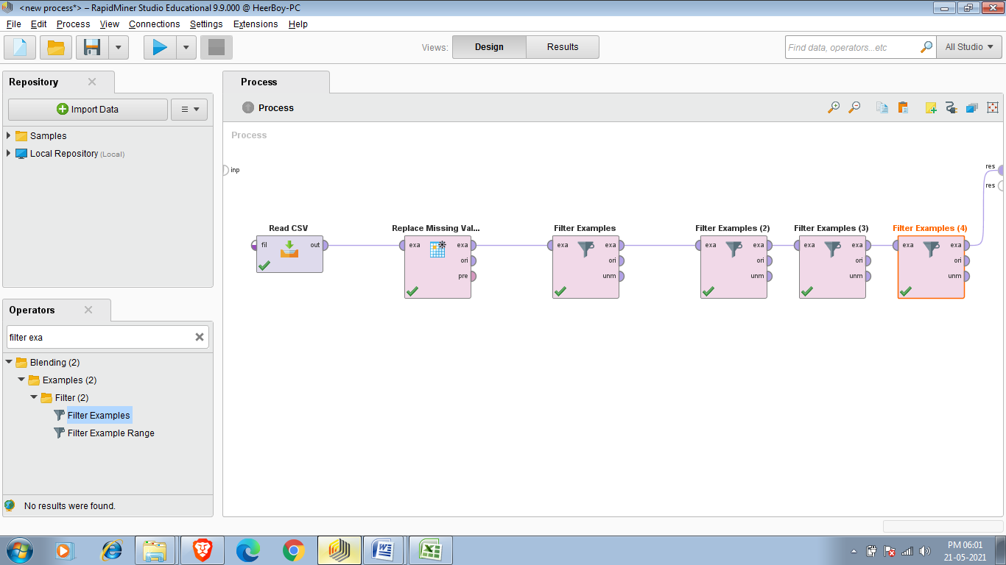

Final Result:-

Final result contains data of 137 old cars from the dataset of 19544 old used cars of cardekho so 137 cars satisfy our all requirements.

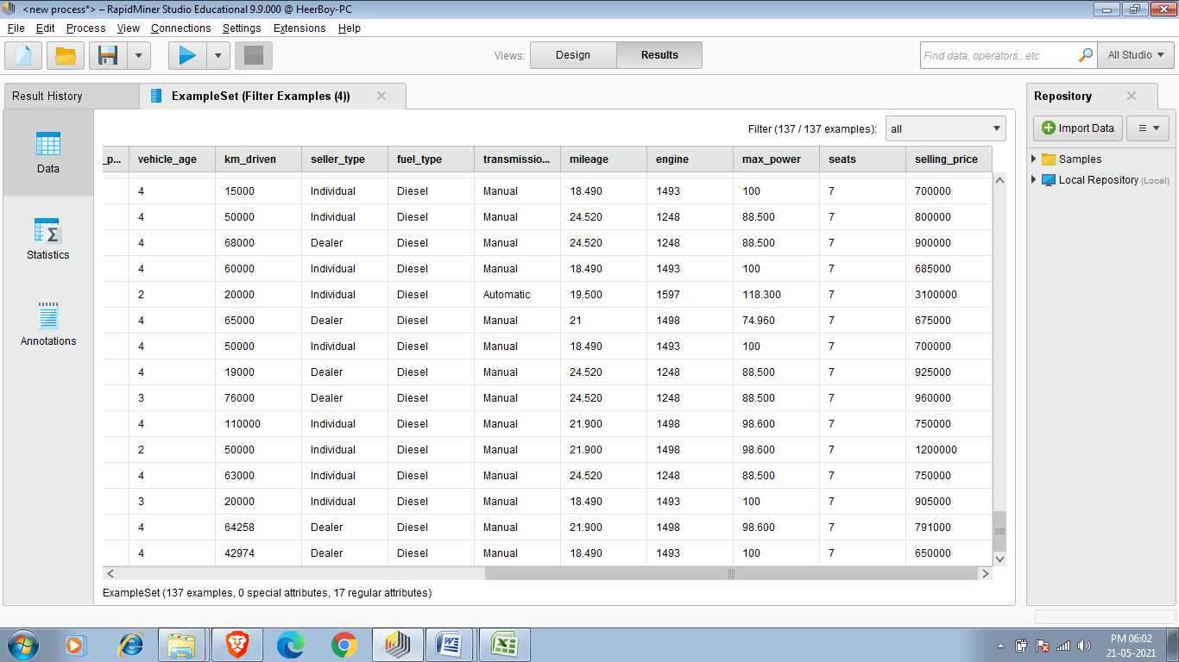

Another operator we can use after Filter Examples .so sample basically create sample set of data which we get after applying Filter Examples and default size of set created by sample operator is 100.

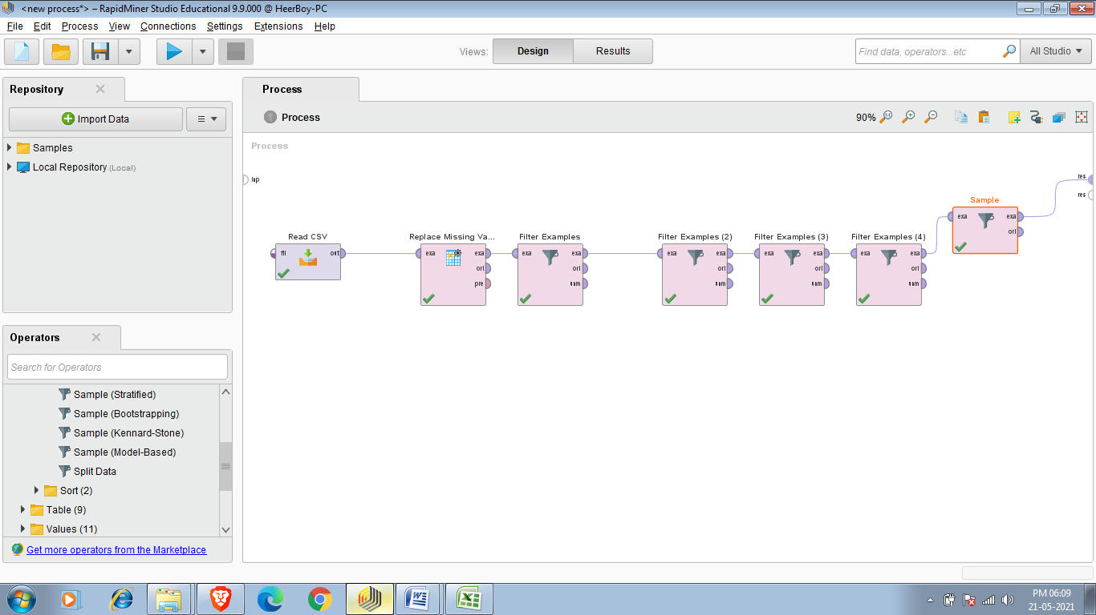

Final Result after applying sample operator:-

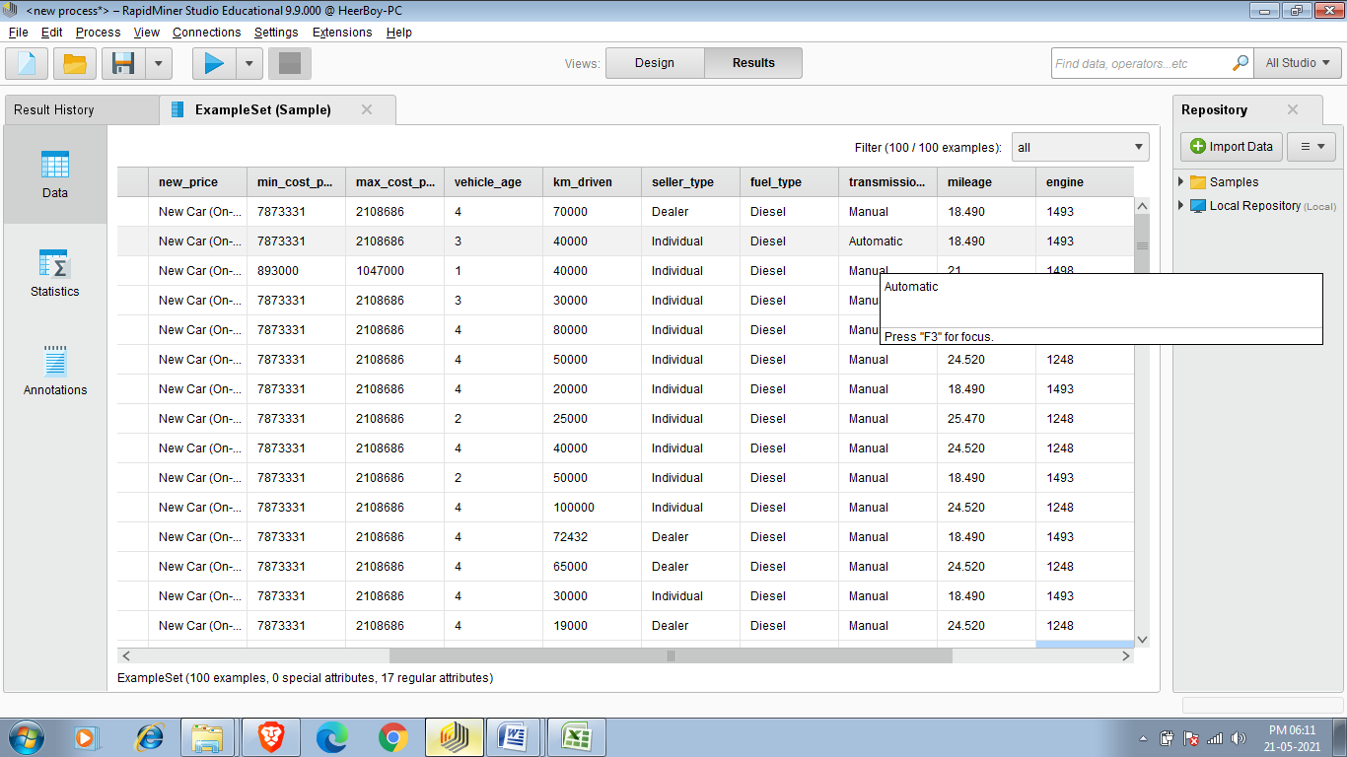

Task 6:-Perform Grouping(data aggregation)

We use aggregate operator to perform grouping.

Aggregate

This operator performs the aggregation functions known from SQL. This operator provides a lot of functionalities in the same format as provided by the SQL aggregation functions. SQL aggregation functions and GROUP BY and HAVING clauses can be imitated using this operator

Now I am performing aggregate function on covid_19_india.csv

My requirement is that i want to see total cured cases as of 2021-05-19.

So first of all i have to apply all operator as i have done in previous task that is sorting so after that to perform grouping we use Aggregate operator that group whole the data and i am am using aggregate attribute cured and aggregate function equal to sum as shown in below fig.

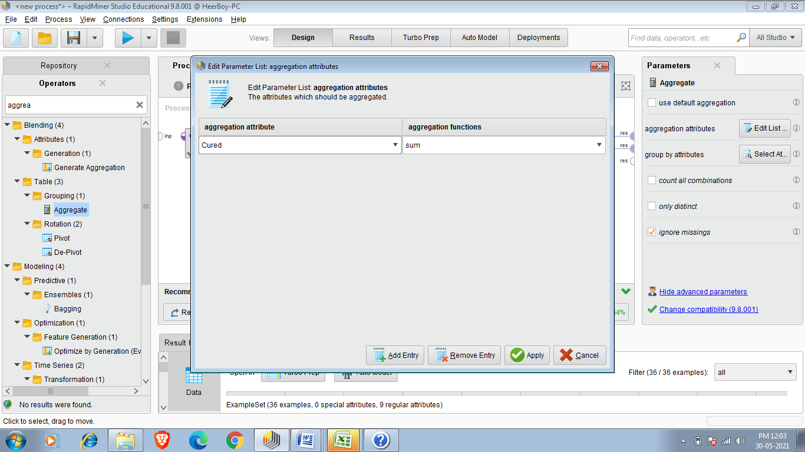

Final Result:-

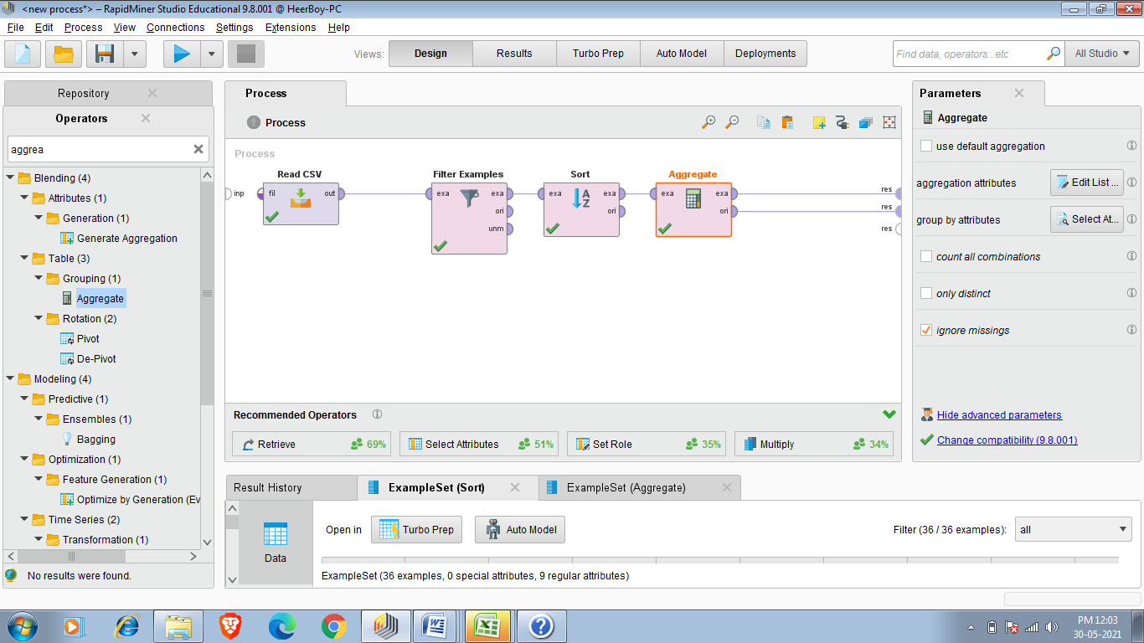

The final Result says total cured cases are 21986363 as of 19 May 2021.

As shown in below image.

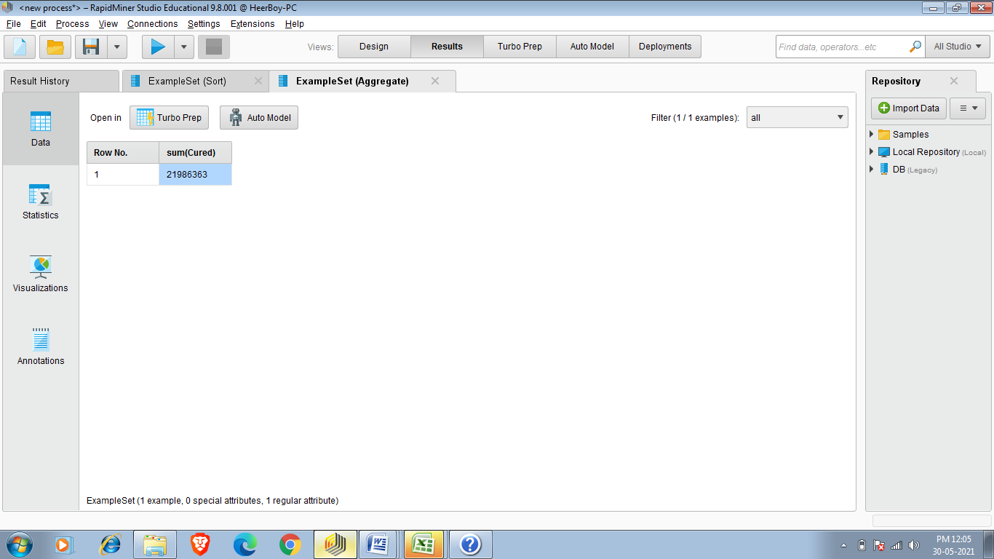

TASK 7 : Correlation

Correlation is a statistical measure of how strong the relationship are between attributes in a dataset.we use Correlation Matrix operator to generate correlation between attributes.It is simply a measure of the strength of the relationship between each possible set of attributes in data set.

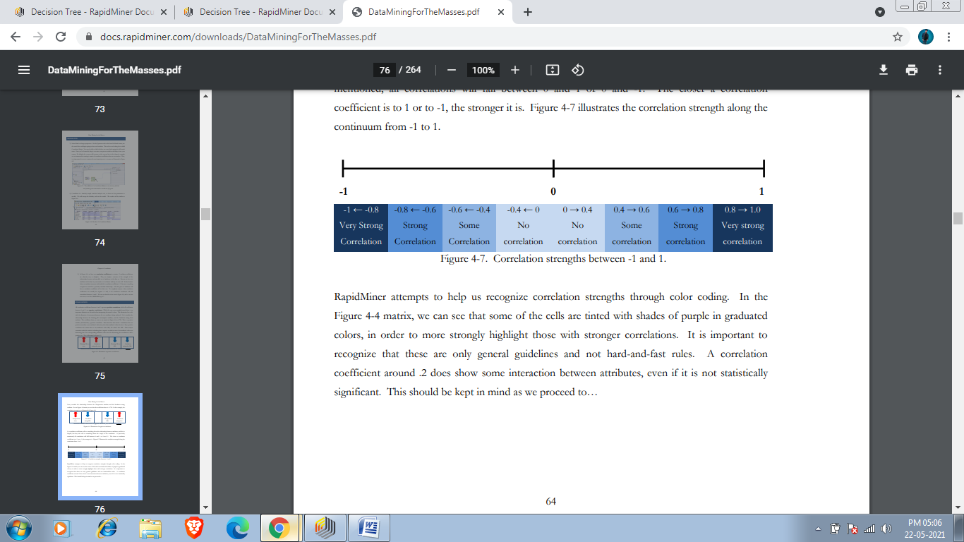

So the problem is that i have to Find Correlation between attribute of android-games.csv dataset.To perform this task first we have add read csv operator as we done in our previous tasks .Then we have to add dataset.

Now to perform Correlation(How much attributes of dataset related to each other) we use Correlation Matrix.just open operator seach panel and search correlation matrix.

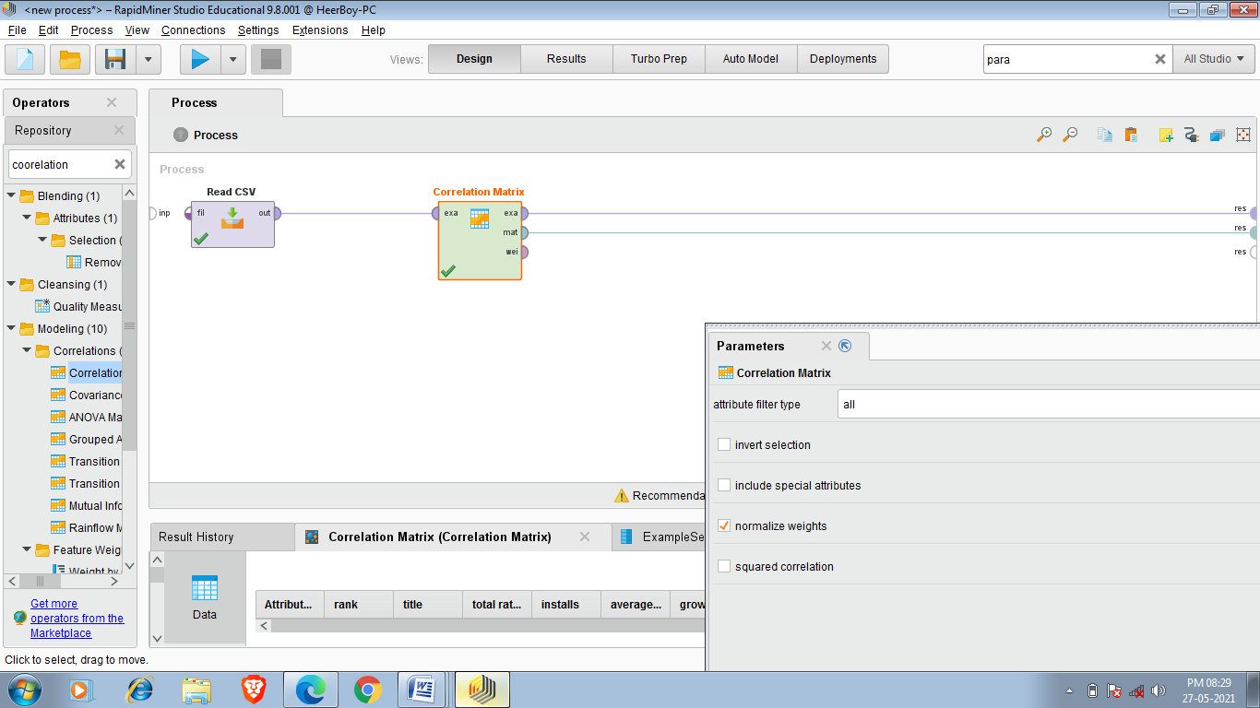 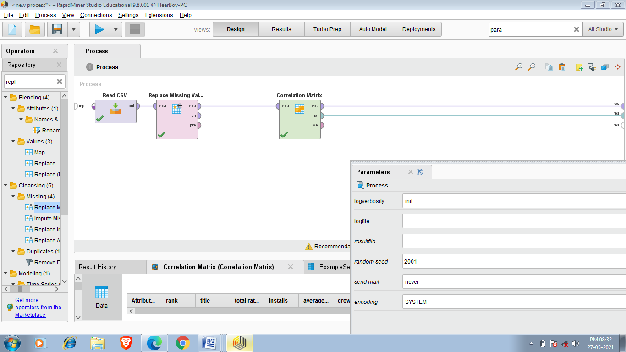

Final Result:-

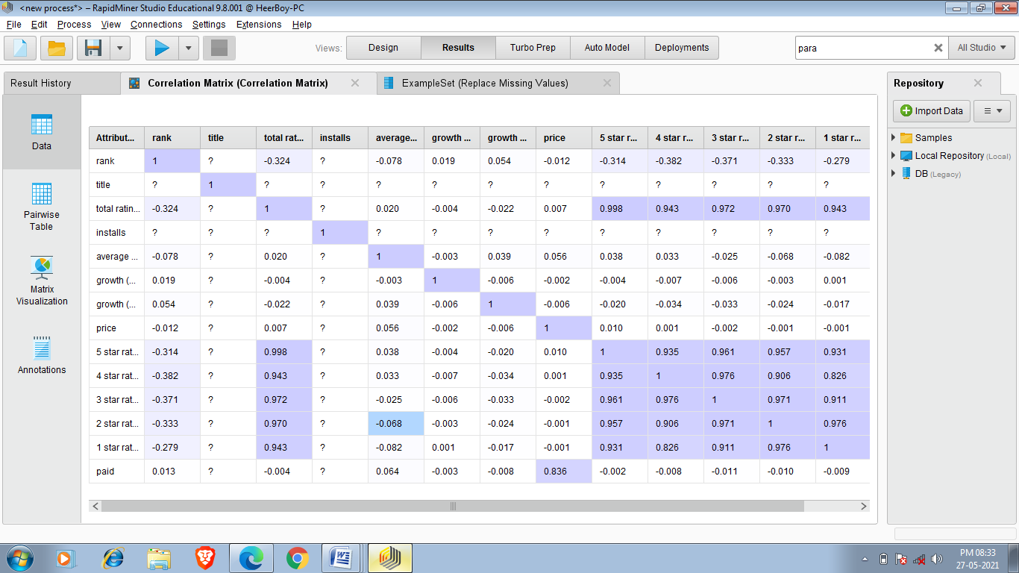

Task 8:Association Rules

Association rules are a data mining methodology that seeks to find frequent connections between attributes in a data set. Association rules are very common when doing shopping basket analysis. Marketers and vendors in many sectors use this data mining approach to try to find which products are most frequently purchased together. If you have ever purchased items on an e-Commerce retail site like Amazon.com, you have probably seen the fruits of association rule data mining. These are most commonly found in the recommendations sections of such web sites.

An example of an association rule would be "If a customer buys eggs, he is 80% likely to also purchase milk." An association rule has two parts, an antecedent (if) and a consequent (then). An antecedent is an item (or itemset) found in the data. A consequent is an item (or itemset) that is found in combination with the antecedent.

Association rules are most common in shopping basket analysis, this modeling technique can be applied to a broad range of questions.

Association rules are created by analyzing data for frequent if/then patterns and using the criteria support and confidence to identify the most important relationships. Support is an indication of how frequently the items appear in the database. Confidence indicates the number of times the if/then statements have been found to be true. The frequent if/then patterns are mined using the operators like the FP-Growth operator. The Create Association Rules operator takes these frequent itemsets and generates association rules.

**Applying Association :-** So to perform Association I am chosing responses(1) data that is more relevant here and after association i tells which product combos have more association.

Now I am applying these association rules on a survey data which contains data of a person and it tells have this person did this thing or not.we will find that have the person who do one task has done another specific task or not.Here support means how many times the particular statement is true and confidence means if person has done particular task then how many times he has done another task.

1.First of all we have to take our dataset and my dataset is responses(1).csv .This data hass urvey of around 3378 people and there responses have they done particular task or not.

Here is my required data set

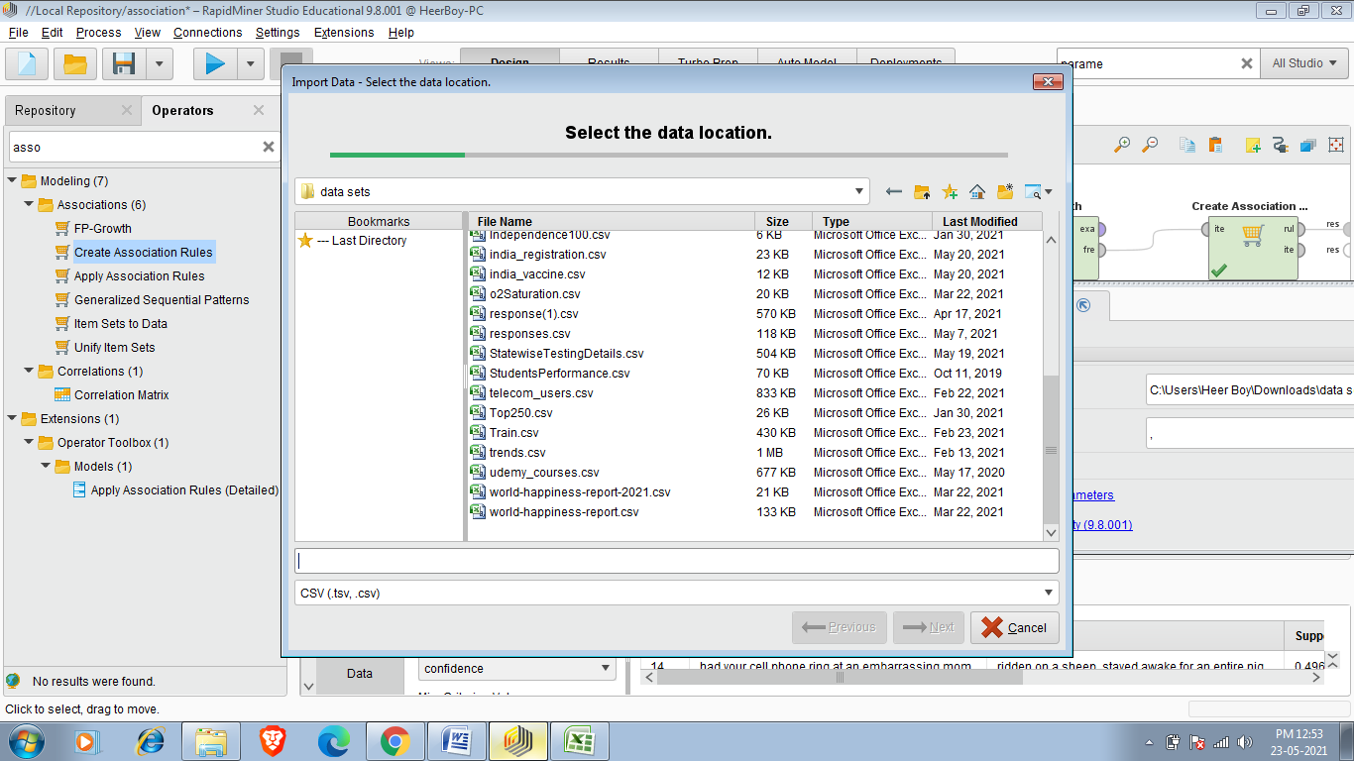

I have to select and add this data set.

2.We have to add select attributes operator and add required attributes as per reqirements.

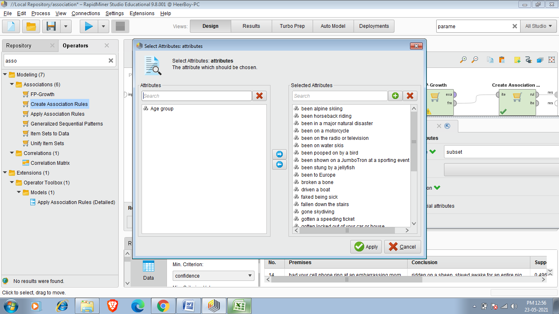

3.Since Association can’t be done on numerical data so we have to add Numerical to Binomial Operator.It converts 0,1 values to True and False.

.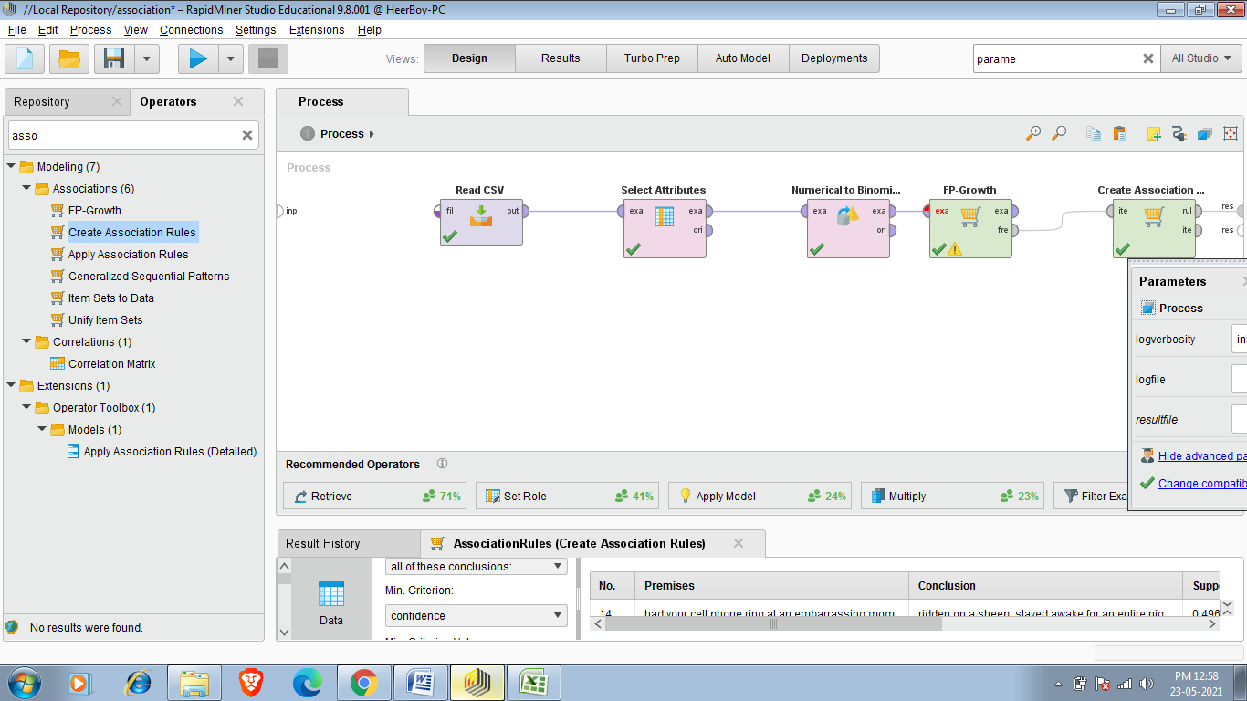

4.For Creating association First we use FP-Growth Operator.

The FP in FP-Growth stands for Frequency Pattern. Frequency pattern analysis is handy for many kinds of data mining, and is a necessary component of association rule mining. Without having frequencies of attribute combinations, we cannot determine whether any of the patterns in the data occur often enough to be considered rules

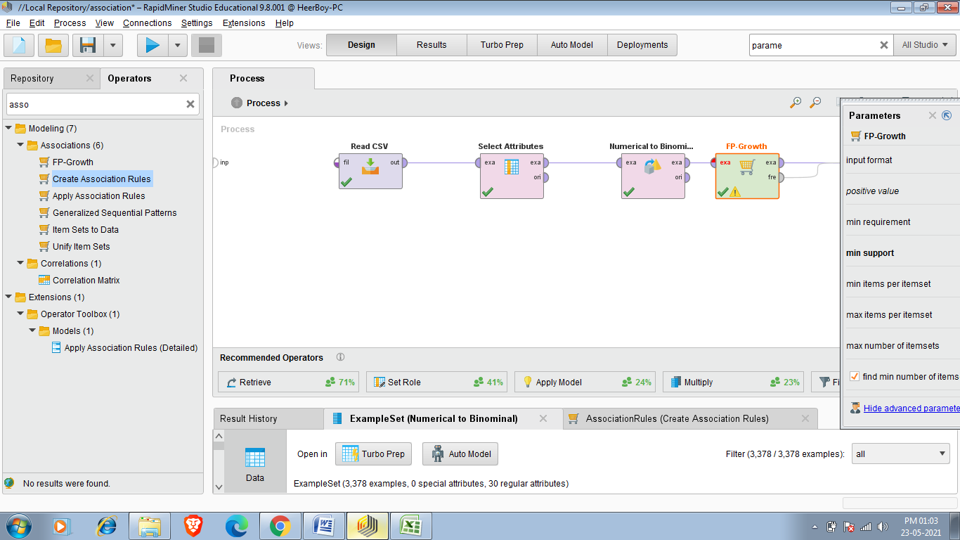

5.So to perform this task we require final operator named as Create Association Rules .We can search it in operator Search panel.Now you can take criterion for Association rule.I am chossing confidence here and the value of confidence i am entering is .8 which means that if person done particular task then the probability that person done another task should be more than .8(80%).

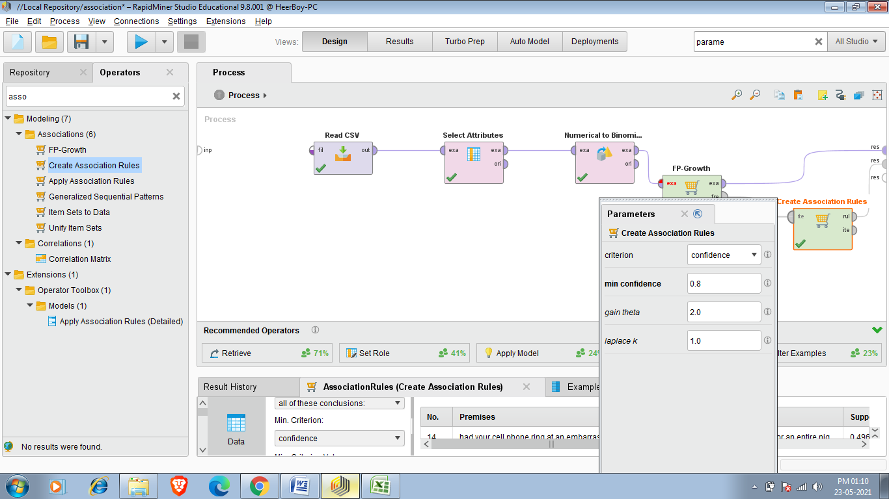

Final Result:-

So final result shows me 238 case whose confidence is more than .8(80% cha nces occurning together). 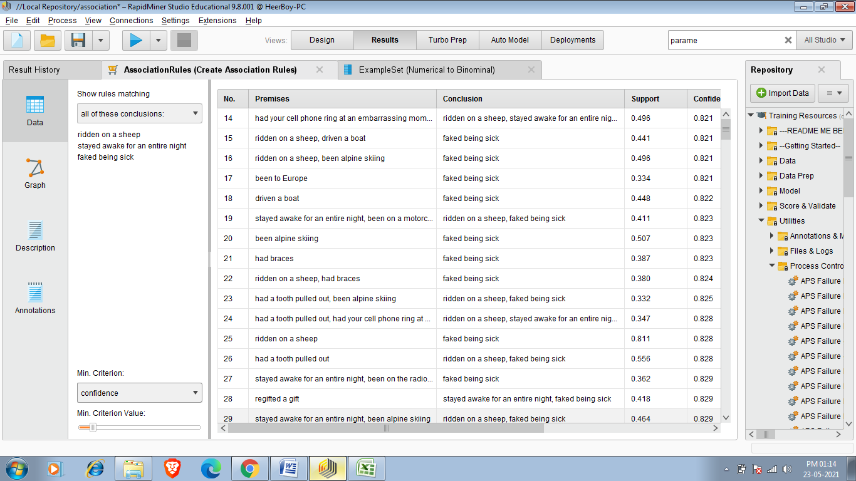

**TasK 9: K-MEANS CLUSTERING**

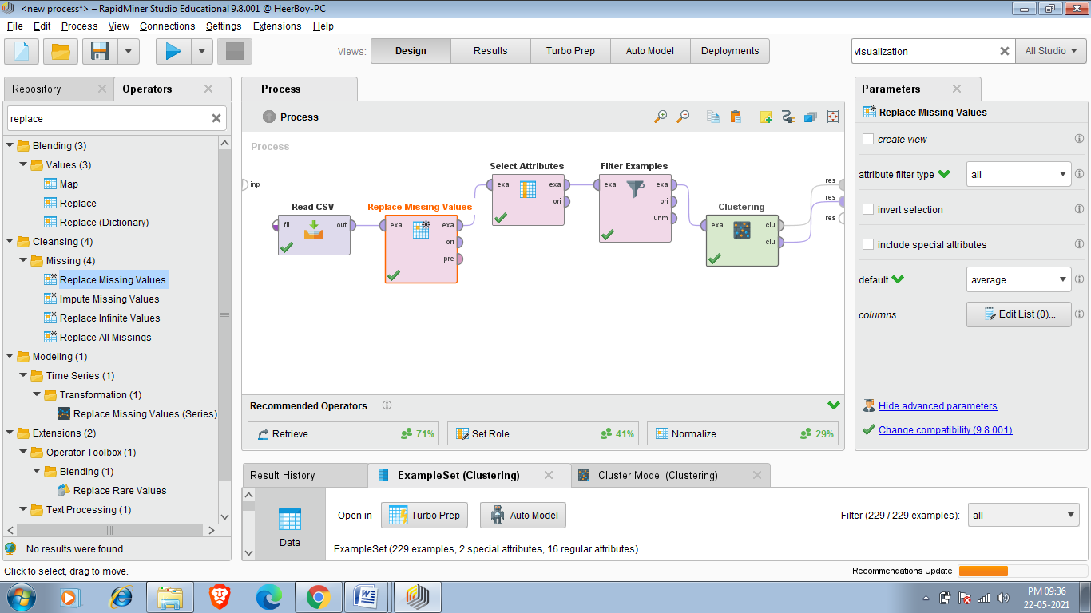

The ‘k’ in k-means clustering stands for some number of groups, or clusters. The aim of this data mining methodology is to look at each observation’s individual attribute values and compare them to the means, or in other words averages, of potential groups of other observations in order to find natural groups that are similar to one another. The k-means algorithm accomplishes this by sampling some set of observations in the data set, calculating the averages, or means, for each attribute for the observations in that sample, and then comparing the other attributes in the data set to that sample’s means.

Now the task is that i want a car whose mileage should be greater than 20,vehicle age should not have to be more than 4 year,engine should be more than 1200 cc (powerful car) and transmission type should be Automatic so i apply all these filter and then form cluster to know about my required car means i have to focus at which cluster that have details about my desired car.So clustering help me to find my desire car

1.First step is to add read csv operator and then add cardekho_cleaned.csv dataset as we done in our previous tasks.

2.After That we have to add Replace Missing Values operator because K-means clustering can’t work on missing values.

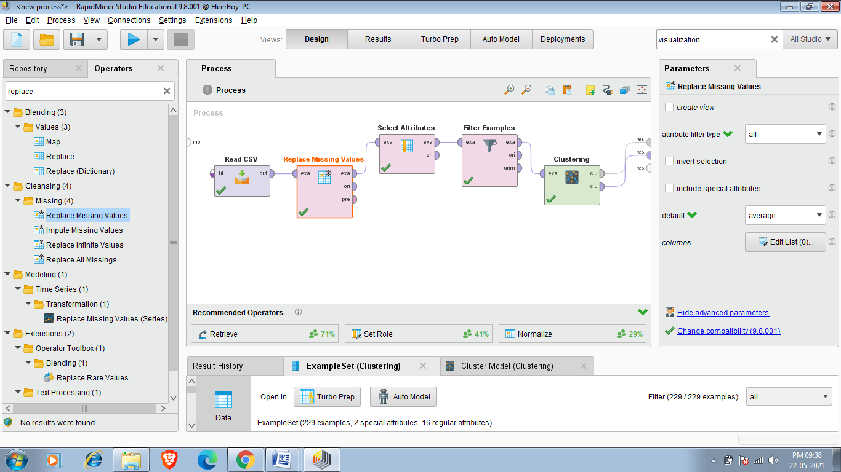

3 After adding Missing Value i can add Select attributes if i want to see only some attributes in our final result.

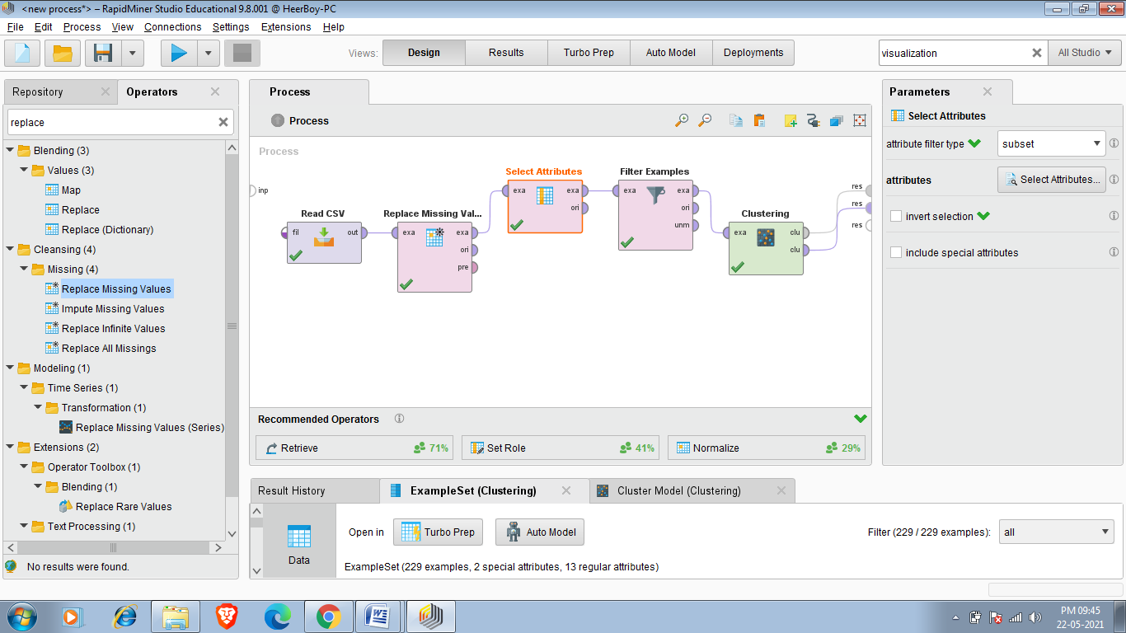

4.So after Applying select Attributes next operator am using is Filter Examples that will help me to find my desired cars ,and i apply all filters as i described before.

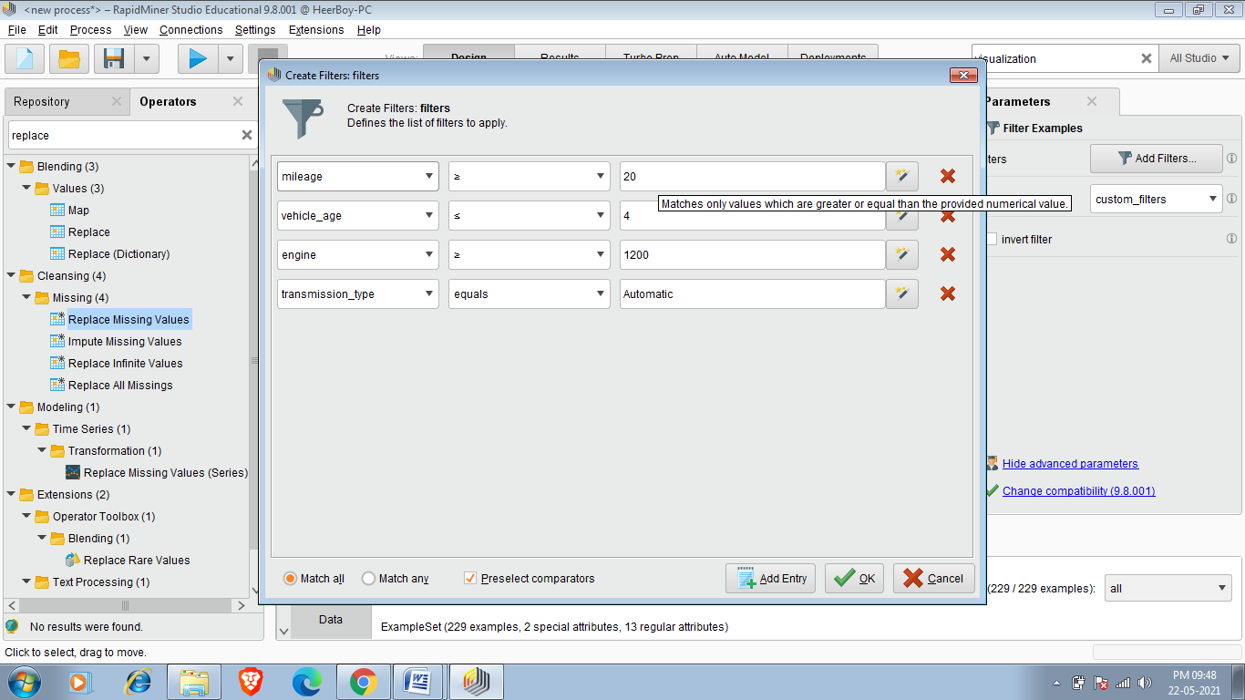

5.Now we have to make clusters and to do that we have to add k-means operator and we add it by searching k-means in operator search panel we can also make cluster of our choice by clicking on clustring operator and then filling no of clusters in k field.I am entering 5 because 5 clusters are enough to analyse my data and making more cluster may slow down my process.

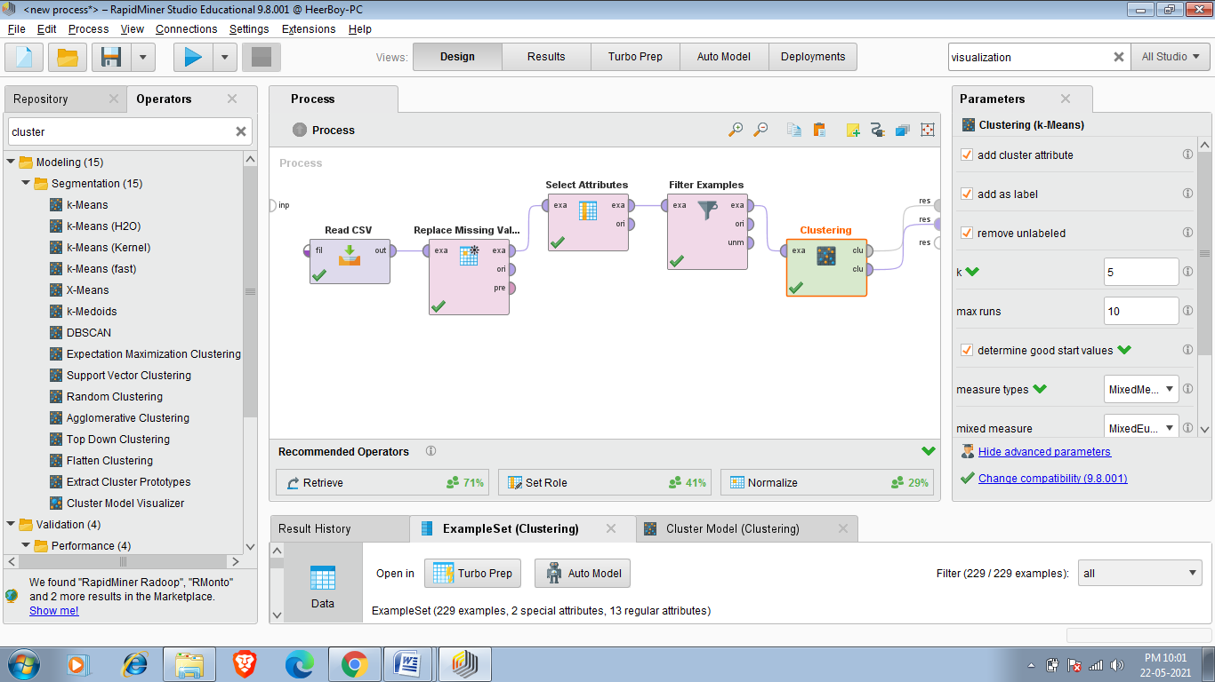

6.So in last i have to make all connections as i listed below.

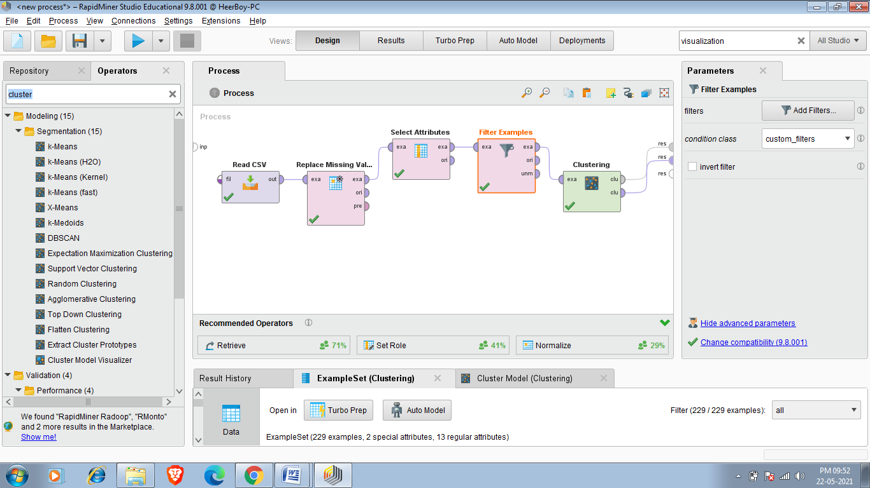

Final Result :-

So our final required dataset has 229 cars as shown below.

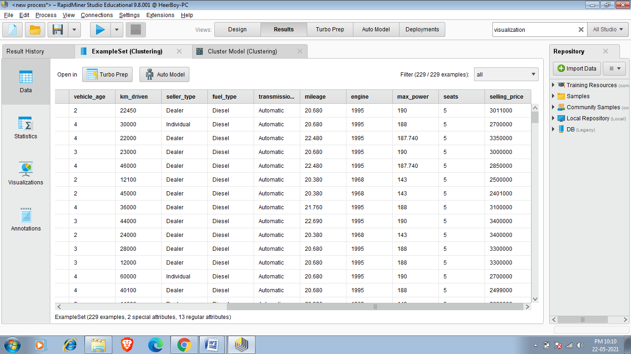

Clusters

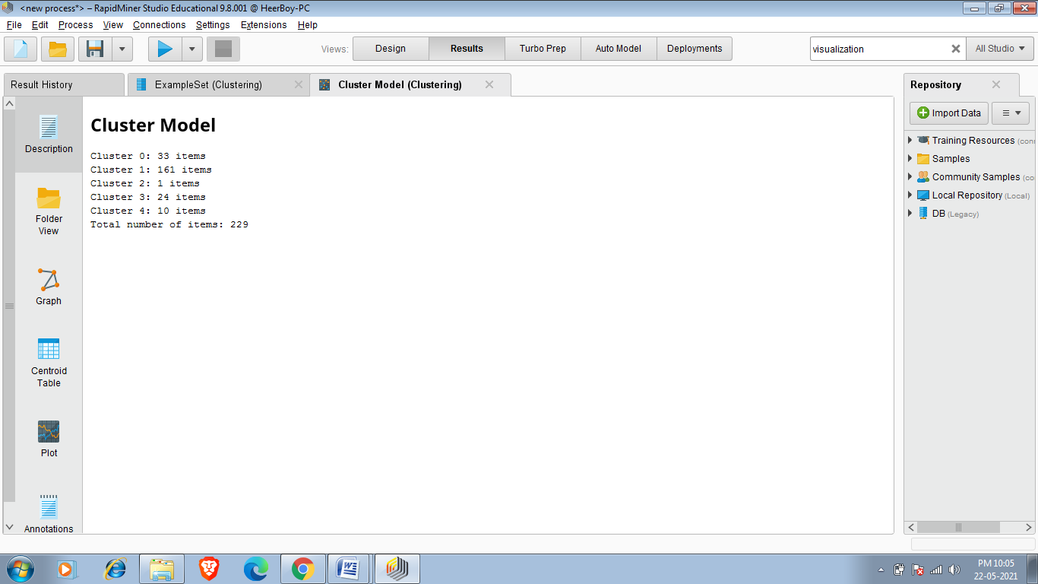

So since i require 5 cluster so Rapid miner created 5 cluster

Centroid Table:-

Centroid Table Contains mean Value of Each Selected Attribute of all cluster The Centroid Table of My required Data set Is Given Below.

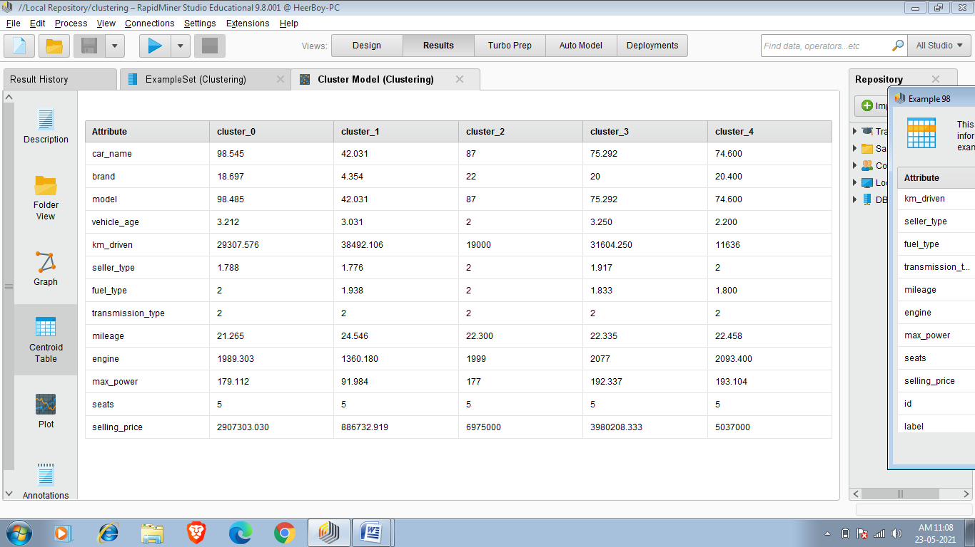

So The centroid Table That Meets my requirement I have to Just give priority To it Because That Cluster have more Relevant result ,so i can easily find my required car on that cluster.

Now i want to buy car whose price is around 10 lakh and should have more mileage ,so i have to check centroid table of all the clusters and i found that cluster_1 has mean price of 886732.919 and mean mileage of 24.546 so its more chances that i focus that i find my result in cluster_1.

Folder view:-

Now i can also see vizualition of single element in this data set i have cars data so i can see visualize view of each and every cars of different clusters.

So i want to see car whose price is near 40 lakh ,so firstly i have to see centroid table where i have o check selling_price and i found that

Cluster_3 has mean selling_price of 3080208.33 ,so its more probability that i find my result in cluster_3 .I can visualize each and every element of cluster_3 By folder View .

Below is visualization view of cars whose price around 40 lakh i can easily find my desired car.

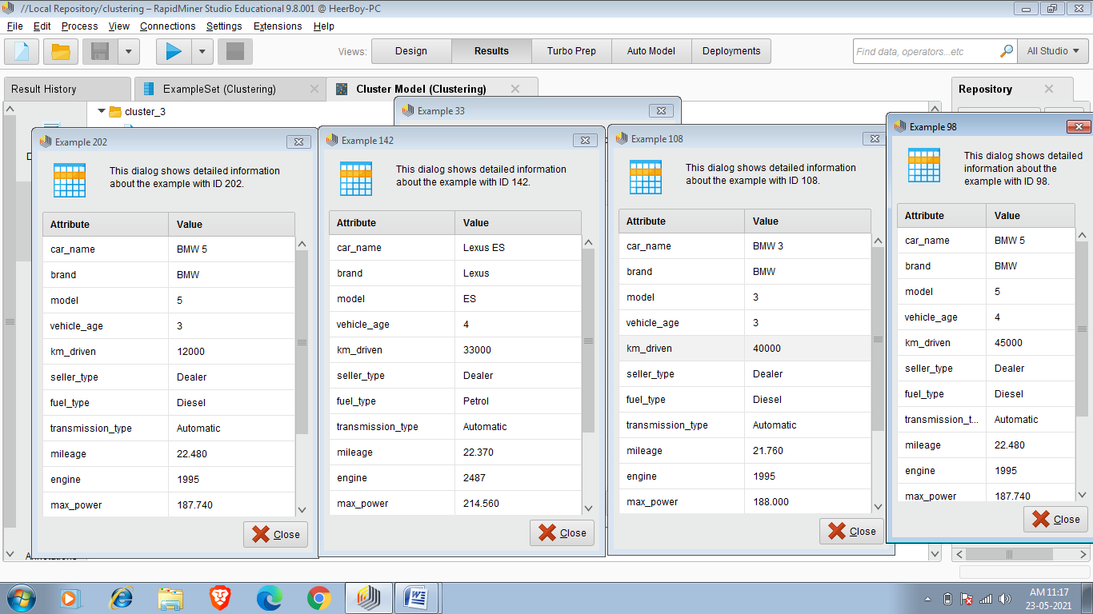

**Task 10:-Naive Bayes Classification**

Naive Bayes is a [machine learning model](https://www.analyticssteps.com/blogs/how-do-exploratory-data-analysis-building-machine-learning-models) that is used for large volumes of data, even if you are working with data that has millions of data records the recommended approach is Naive Bayes. It gives very good results when it comes to NLP tasks such as [sentimental analysis](https://www.analyticssteps.com/blogs/sentiment-analysis-youtube-comments). It is a fast and uncomplicated [classification algorithm](https://www.analyticssteps.com/blogs/introduction-xgboost-algorithm-classification-and-regression).

To understand the naive Bayes classifier we need to understand the Bayes theorem. So let’s first discuss the Bayes Theorem.

## **Bayes Theorem**

It is a theorem that works on conditional probability. [Conditional probability](https://www.analyticssteps.com/blogs/conditional-probability-definition-properties-examples) is the probability that something will happen, given that something else has already occurred. The conditional probability can give us the probability of an event using its prior knowledge.

### **Conditional probability:**

### 

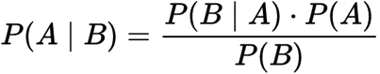

Conditional Probability

Where,

P(A): The probability of hypothesis H being true. This is known as the prior probability.

P(B): The probability of the evidence.

P(A|B): The probability of the evidence given that hypothesis is true.

P(B|A): The probability of the hypothesis given that the evidence is true.

Implement Naive Bayes and Performance in Cardekho_cleaned(new).csv dataset.

This dataset is latest data set updated on 20 may 2021.

So to perform Naive Bayes algorithm first we read data from read CSV operator.As shown below.

Required dataset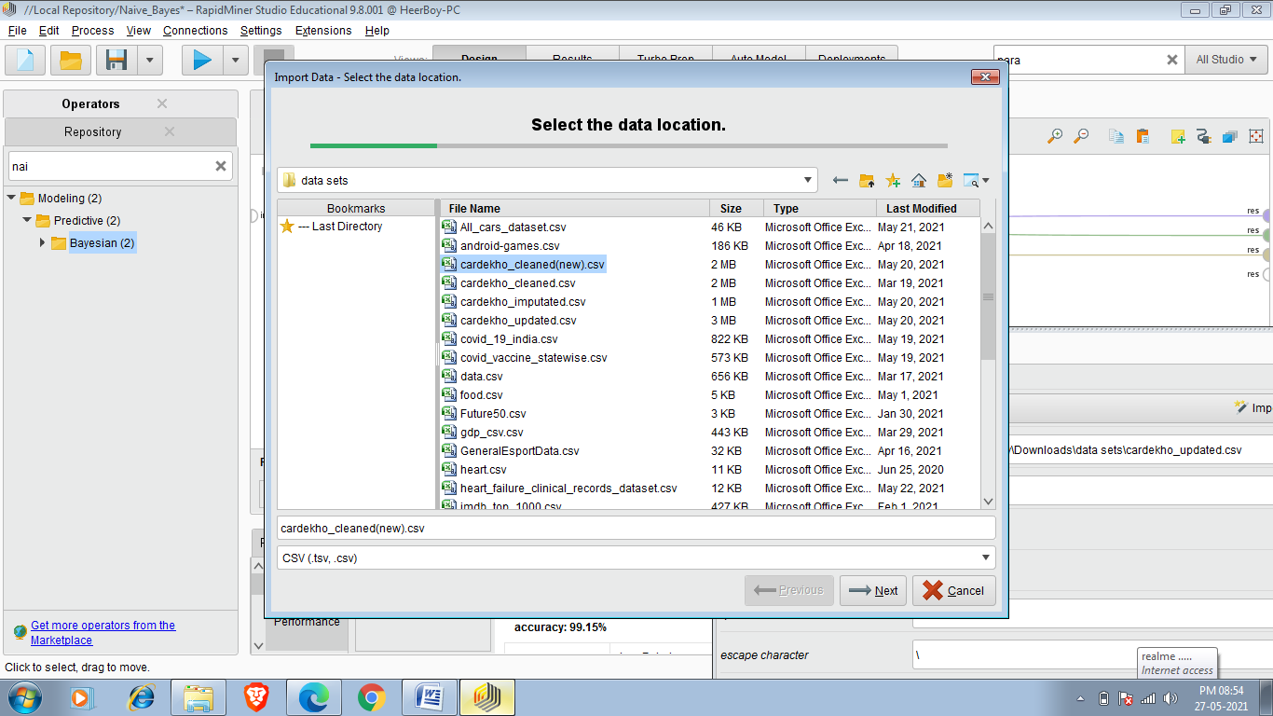

After that you can choose Attribute which you have to classify you can make that attribute as label and we can do it by 2 methods ,in first method we can change the role of attribute at importing time and another one is set role and i choosing set role and the attribute that i choose for classification of set it fuel type.

In below figure i have choosen fuel_type as label.Now classification has to done on the basis of fuel_type attribute.

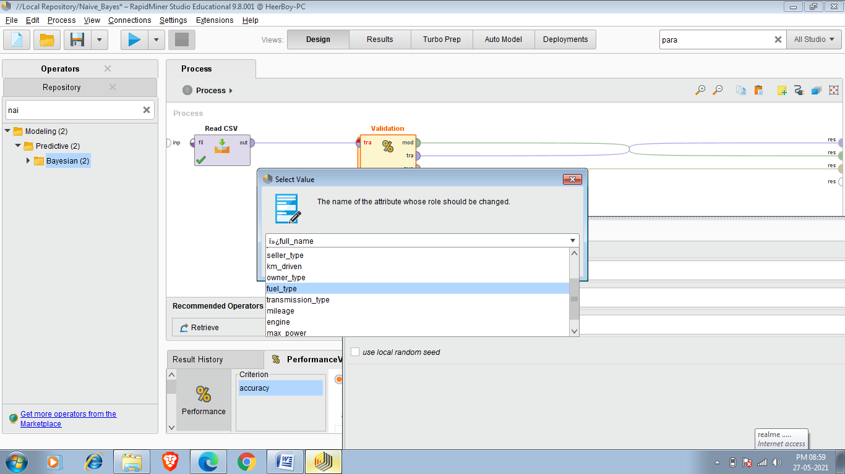

Now after setting role we have to insert Split Validation operator and the operator is shown below

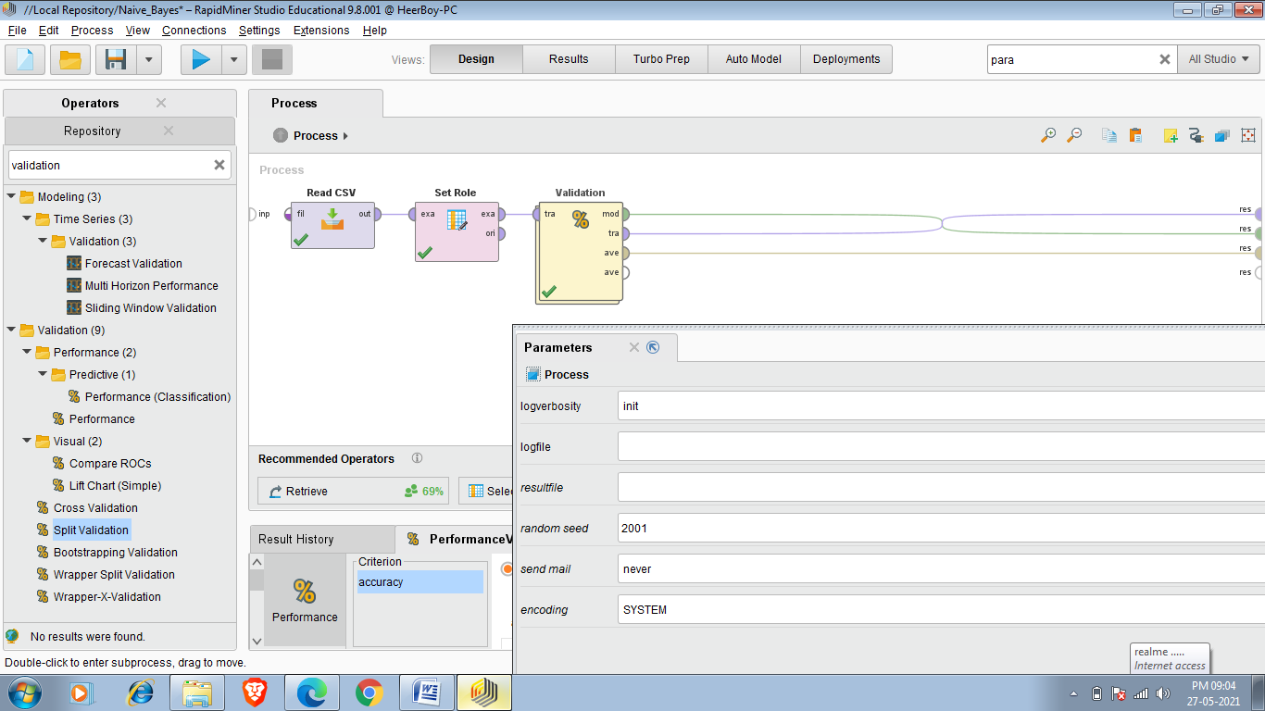

Split Validation operator performs a simple validation i.e. randomly splits up the ExampleSet into a training set and test set and evaluates the model. This operator performs a split validation in order to estimate the performance of a learning operator (usually on unseen data sets). It is mainly used to estimate how accurately a model (learnt by a particular learning operator) will perform in practice.

So now when we inserted this operator then this operator randomly splits the Example set to training and testing as shown in below figure.

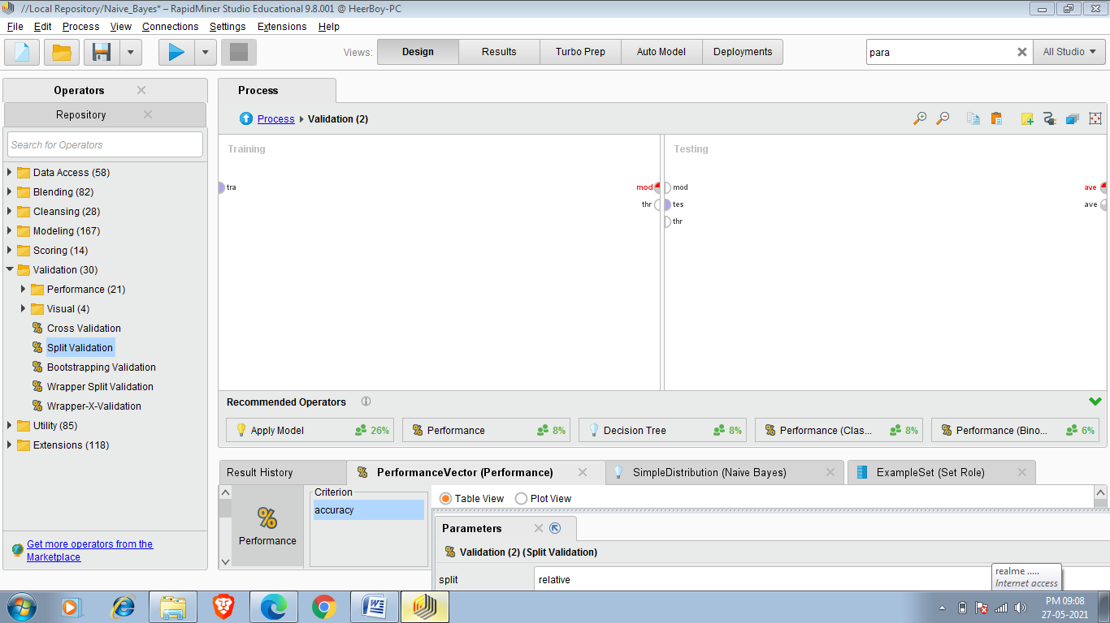

Now we have to apply Training and Testing operation so

Firstly we have to add Naive bayes to training set and then apply model and Performance to Testingset and we have to do connections as i shown in below picture.

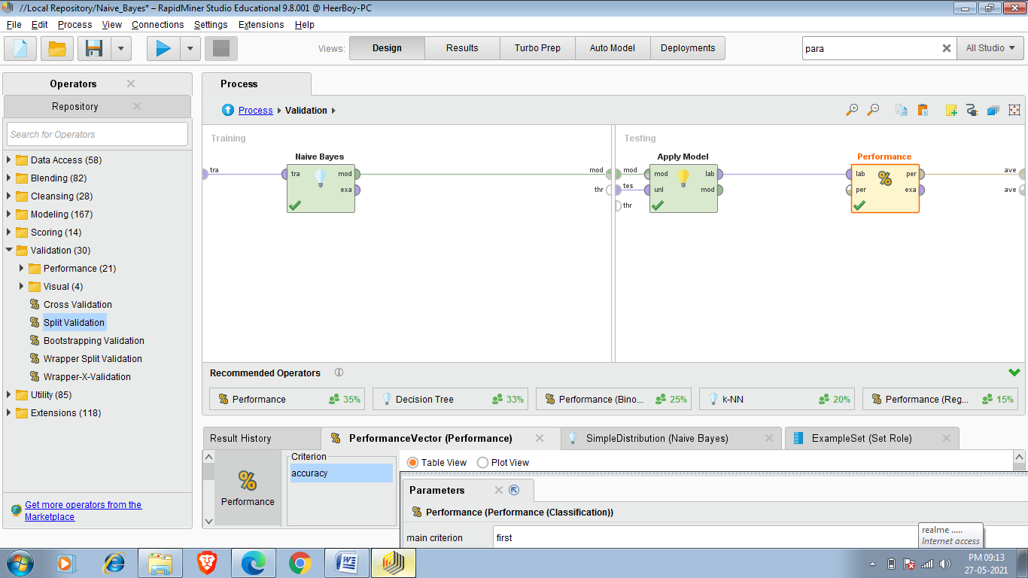

Now the process look like as shown in below picture.

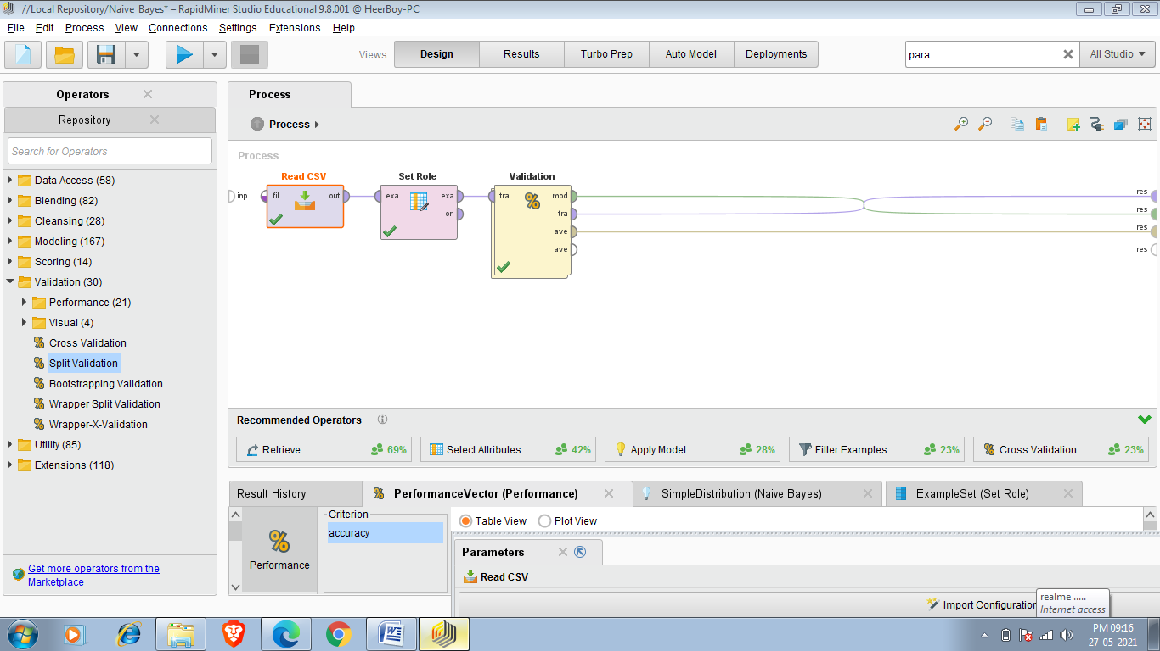

Final Result:-

Naive Bayes Classification:-

In below figure we see Naive Bayes classification classified according to the label which is Fuel_type

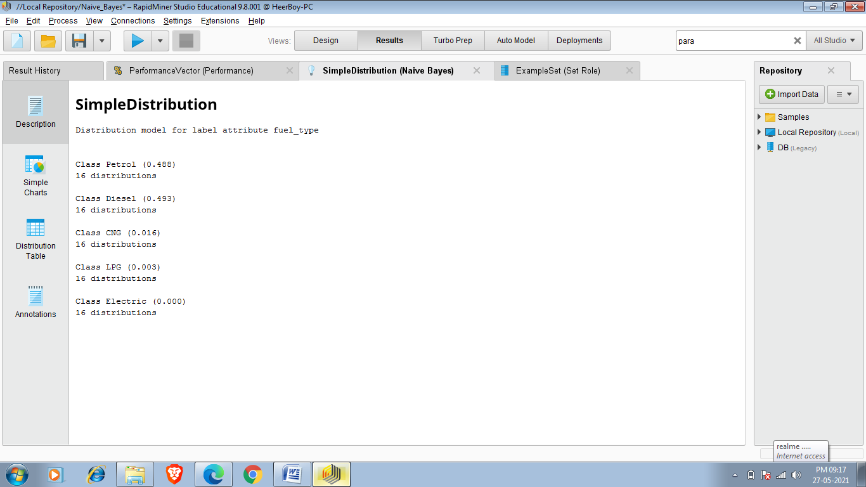

So this SimpleDistribution Simply Defines the probability and no. Of distributions.We see that petrol cars has 0.488% probability which means approximately 48.8% has fuel_type petrol in this Dataset.

DISTRIBUTED TABLE:-

This table shows the probability of different attributes when fuel_type is petrol ,diesel ,CNG,LPG or Electric.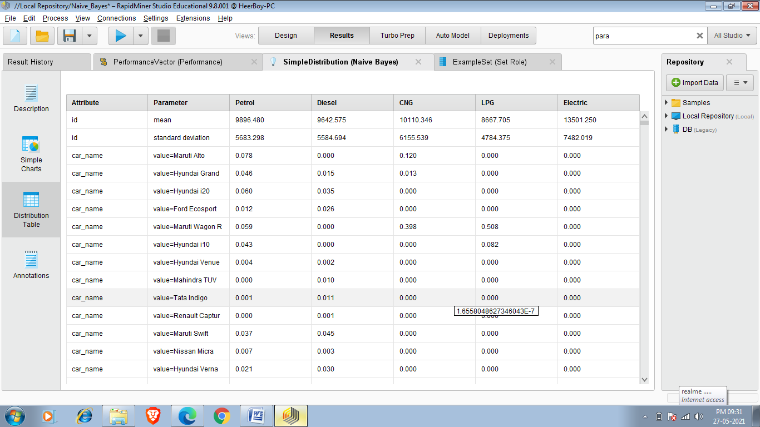

So in the above result when se to 3rd row 3rd column it is showing that probability of a car whose name is Maruti alto/ In the whole Petrol car(when car fuel_type is petrol)

And the value is 0.078% which means the car whose model is Maruti alto is only 0.078 % of whole petrol cars.

Performance:-

This operator is used for performance evaluation. It delivers a list of performance criteria values. These performance criteria are automatically determined in order to fit the learning task type.

In contrast to the other performance evaluation operators like the Performance (Classification) operator, the Performance (Binominal Classification) operator or the Performance (Regression) operator, this operator can be used for all types of learning tasks. It automatically determines the learning task type and calculates the most common criteria for that type. For more sophisticated performance calculations, you should use the operators mentioned above. If none of them meets your requirements, you can use Performance (User-Based) operator which allows you to write your own performance measure.

The following criteria are added for binominal classification tasks:

* Accuracy
* Precision
* Recall
* AUC (optimistic)
* AUC (neutral)
* AUC (pessimistic)

The following criteria are added for polynominal classification tasks:

* Accuracy
* Kappa statistic

The following criteria are added for regression tasks:

* Root Mean Squared Error
* Mean Squared Error

I also used performance operator in the above task and the results are below:-

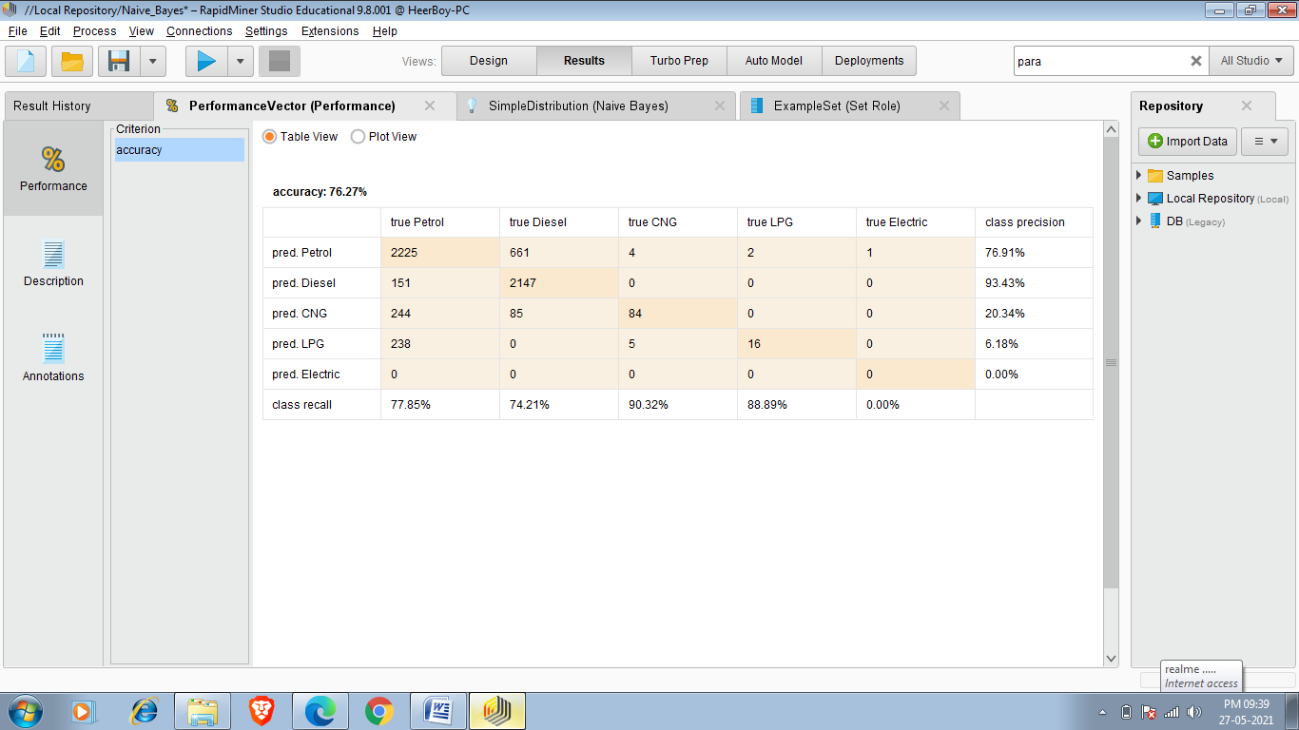

Accuracy is calculated by taking the percentage of correct predictions over the total number of examples. Correct prediction means examples where the value of the prediction attribute is equal to the value of the label attribute. If you look at the ExampleSet in the Results Workspace, you can see that there are it the accuracy of pred Petrol is 76.91% and the model has 76.27% accuracy which means it predicted 76.27% fuel_type of car rightly.

**Task 11:Decision Tree**

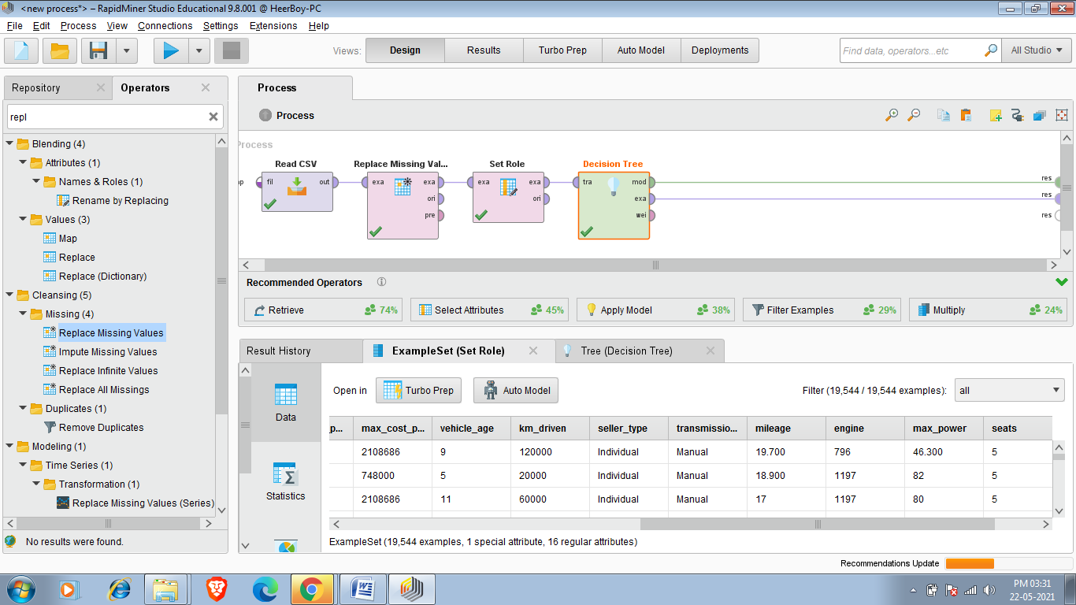

This Operator generates a decision tree model, which can be used for classification and regression.

Description

A decision tree is a tree like collection of nodes intended to create a decision on values affiliation to a class or an estimate of a numerical target value. Each node represents a splitting rule for one specific Attribute. For classification this rule separates values belonging to different classes, for regression it separates them in order to reduce the error in an optimal way for the selected parameter *criterion*.

The building of new nodes is repeated until the stopping criteria are met. A prediction for the class label Attribute is determined depending on the majority of Examples which reached this leaf during generation, while an estimation for a numerical value is obtained by averaging the values in a leaf.

This Operator can process ExampleSets containing both nominal and numerical Attributes. The label Attribute must be nominal for classification and numerical for regression.

Now to perform this task am am using covid_vaccine_statevise.csv data set. This data set contains vaccination datails of all the states upto 19 May 2021.

So i want to show tota individual vaccinated of Maharashtra of different age group

So first of all i have to add data set and there after i have to select desired attributes according to requirements.I have choosen as per my requirement as shown below.

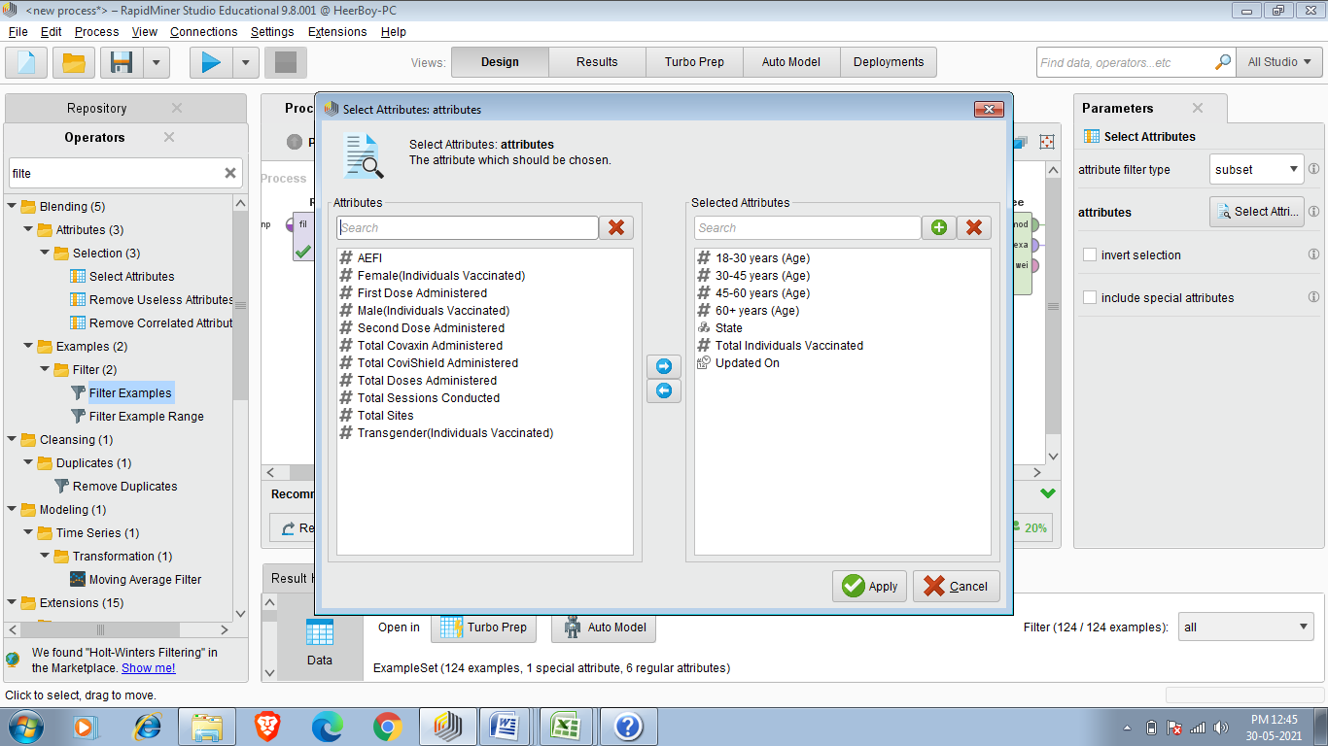

I want to see total individual vaccinated according to age group in Maharashtra .so i am choosing it as label as shown below

+

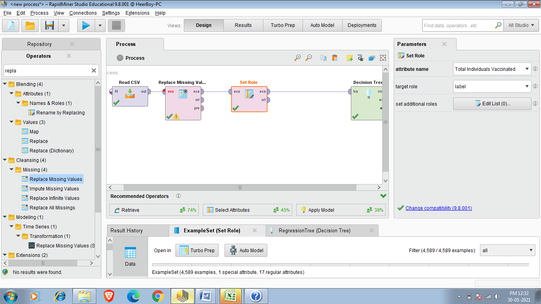

Now i only want to see Maharashtra Record so i am applying filter as shown below:-

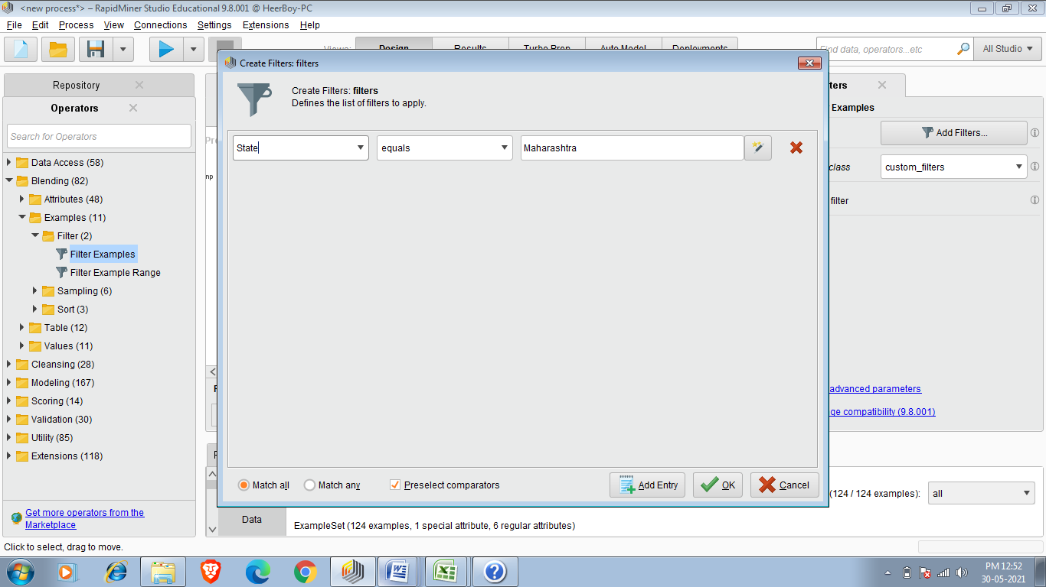

So after that i have to add decision tree operator and final process look as shown below.

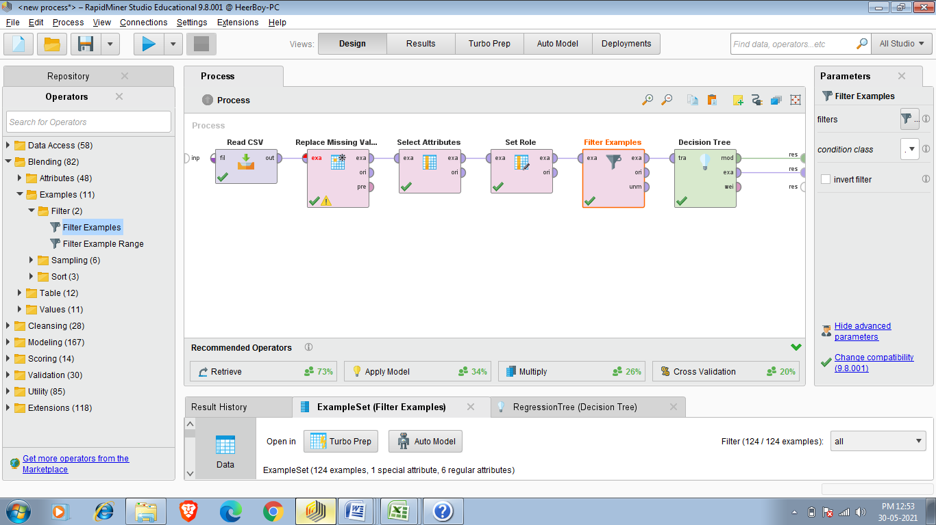

Final Result:-

So This Decision tree shows Total individual vaccinated of different age group In Maharashtra.

